Schism the Unification Movement:
The Theological Dimensions (an insider’s view)

By Dan Fefferman
International Coalition for Religious Freedom

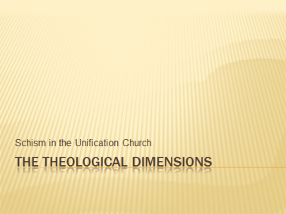
The current schism in the Unification Church movement is basically an expression of a struggle for succession, with Rev. Moon’s eldest son Hyun Jin (Preston) leading one side and Rev. Moon’s wife and younger sons on the other. Historians of religion have long known that power struggles affect theological controversies and are in turn affected by them. The situation in the Unification Movement today provides an opportunity to study this process at first hand.

Several disclaimers: First, I am both Unificationist and a proponent of the “Church” side of the current controversy. I have done my best to be objective in this presentation, but I am sure there will be some on the other side of the schism who will find reason to criticize what I say here. I hope the organizers will provide an opportunity for responsible spokespersons from the other side to respond if they so desire. Second, this paper examines the distinctions between the two camps. It thereby exaggerates the differences while downplaying the common ground. I will look at some of the commonalities in the final section of this paper. Third, there is considerable crossover and overlap between the two sides. Especially, many UC members sympathize with some of the theological positions of the GPFF movement but remain loyal to the UC leadership on grounds of tradition and obedience.

The practical details of the schism have been covered in this conference by Prof. James Beverley of the Tyndale Theological Seminary. I will deal with them mainly as they affect the theological question of Ecclesiology. Other topics I will cover include Christology, Soteriology, Scriptural Canon, Sacramental Theology, Authority, Political Theology and the particularly Unificationist topic of Providential Paradigms.

Finally a word about terminology: “Unification Church” is officially accepted by the UC side. However those who follow Hyun Jin (Preston) Moon have not yet decided what they should be called. They universally object to the negative appellation of “Kwak Group.” I will thus refer to them either as members of the Global Peace Festival Foundation (GPFF movement) or as supporters/followers of Hyun Jin Moon (Preston).

I should also say a word about methodology. This being a conference on New Religious Movements it is only natural to speak in theological terms. However, it is important to note at the outset that one side in the current schism holds that it is a mistake for the Unification Movement to define itself as “religion.” This could create a methodological bias in favor of the “church” side of the schism, and such a potential bias ought to be kept in mind.

The trends I have identified are not necessarily permanent. “Orthodoxy” it is said, “proceeds on the left foot of heresy.” The tendency to react is often followed by a movement to embrace. For example, in Christian history, the orthodox church rejected the “judaizers” but accepted the Old Testament as sacred scripture. It rejected Gnosticism but accepted some aspects of its dualistic cosmology. It rejected asceticism as necessary to salvation, but found a place for monasticism. It rejected the idea that Christ was anything less than God the Son, but eventually insisted that he also be considered fully human. Thus, whatever the outcome of the power struggle in the Unification Movement, we can expect that the current theological tendencies will not only diverge and conflict but also engage in assimilation and symbiosis.

Ecclesiology

- Religion or Movement?
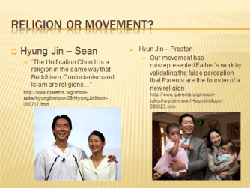
The question as to whether one should speak of Unificationism as a “religion” or a “movement” is central to the controversy. Hyung Jin (Sean), the younger son appointed by Rev. Moon as his successor states: “The Unification Church is a religion in the same way that Buddhism, Confucianism and Islam are religions…” Hyun Jin (Preston), the eldest surviving son, insists that “Our movement has misrepresented Father’s work by validating the false perception that Parents are the founder of a new religion”
- Emblematic emblems
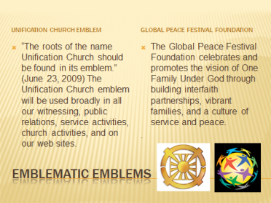
The “religion vs. movement” controversy is further exemplified by the organizational titles and emblems that represent each faction. The UC has clearly laid to rest its former policy of doing business as the “Family Federation for World Peace” and has decided once again to hoist the “church flag.” As Rev. Moon said on June 23, 2009, “The roots of the name Unification Church should be found in its emblem.” The next month a memo from Hyung Jin (Sean) in his capacity as International President of the UC, stated: “The Unification Church emblem will be used broadly in all our witnessing, public relations, service activities, church activities, and on our web sites.” The flagship project of Hyun Jin (Preston), the Global Peace Festival Foundation, on the other hand, provides a completely non-sectarian vision statement: “The Global Peace Festival Foundation celebrates and promotes the vision of One Family Under God through building interfaith partnerships, vibrant families, and a culture of service and peace.” Meanwhile, the GPFF’s primary funding source, formerly known as Unification Church International, now calls itself simply “UCI.” This corporation also removed from its statement of purposes all references to teaching the Divine Principle and supporting the Unification Church.

- Mission
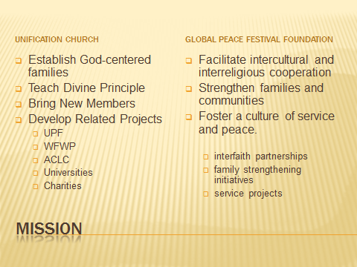
Missiology is the area of practical theology that investigates a church’s mandate, message, and mission, especially the nature of missionary work. Here, both sides of the schism affirm a commitment to work for God-centered families. However, the UC defines this more specifically in terms of witnessing to Rev. and Mrs. Moon as the True Parents, teaching Divine Principle, and bringing people to the church’s sacrament of the Blessing. The GPFF and UCI define their mission more broadly. GPFF’s public literature does not refer to the Moons as True Parents but speaks more generally to the need for strong families and communities to establish the ideal of One Family Under God. It is also fair to say that the GPFF places service and educational projects more toward the center of its mission, while the UC places them in a more secondary position. At the same time, due to its longer institutional history and greater financial resources, the UC side has created a more substantial network of supporting organizations, charities and educational institutions.
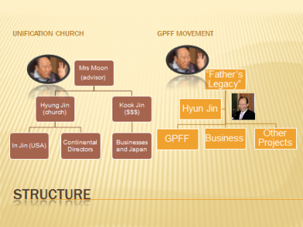
- Structure
Structurally, both sides appeal internally to the authority of Rev. Moon. While Rev. Moon was still living, the Church side had a clear advantage in this regard, as Rev. Moon himself supported the Church. This caused the GPFF side to claim that Rev. Moon was being manipulated or misled by his “handlers,” especially including his son Kook Jin and by implication Mrs. Moon and Hyung Jin (Sean).
Today the Church side sees Mrs. Moon as the supreme authority, advised by her husband from the spiritual world. Hyung Jin (Sean) is the formal head of the international church, while Kook Jin is in charge of the movement’s finances and related businesses, with special responsibility for Japan, which remains a main funding source for the worldwide movement. The GPFF side emphasizes the concept of “Father’s legacy” as opposed to the authority of Mrs. Moon. Its earthly leader is Hyun Jin (Preston). The Church side alleges that Hyun Jin is strongly influenced by his father-in-law, Rev. Chun Hwan Kwak, together with other members of the Kwak family. It points out that the majority of UCI’s board members are relatives and in-laws of Rev. Kwak.
Christology
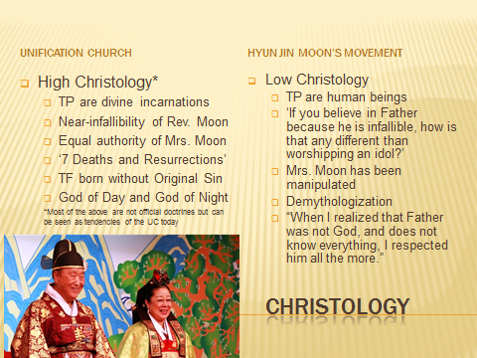
We turn now to a more purely theological topic: Christology, or the nature of the Messiah, sometimes called “Moonology” by students of Unificationism. Is the Messiah (Moon) merely a man, or an incarnation of God? Does he make mistakes? On these questions we must tread carefully, because Rev. Moon has only recently passed away, and the theological lines of the schism overlap in this area. Nevertheless some broad outlines appear to be emerging, or at least germinating.
As might be expected, the Church side of the schism tends to a higher Christology, while the GPFF movement tends toward a lower one. In other words:
- The Church side tends to emphasize the divinity of the True Parents, while the followers of Hyun Jin Moon emphasize their humanity.
- The Church side tends to see the Messianic couple as more or less infallible, while the GPFF side sees them as more capable of being misled. Hyun Jin (Preston) exemplified the latter attitude when he declared: “‘If you believe in Father because he is infallible, how is that any different than worshipping an idol?”
- The Church side emphasizes Mrs. Moon’s equal authority and co-messiahship with Rev. Moon, while the Movement side speaks more of Hyun Jin Moon as the inheritor of “Father’s legacy” who understands Rev. Moon’s teaching best.
- The Church side has begun developing a sacred mythology of Rev. Moon’s life that emphasizes his divine nature, such as the concept of the “7 Deaths and Resurrections” and the idea of the “God of the Night and the God of the Day.” The GPFF side tends toward the demythologization of Rev. Moon.
It should be stressed that many on the Church side of the schism do not go along with some or all of the above-mentioned tendencies toward a high Christology. However, few on the GPFF side cross over to embrace the trends.
Soteriology
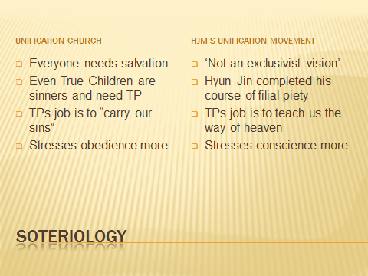
Soteriology describes a religion’s doctrine of Salvation. Here we can say that the Church side tends more toward a theology of grace, while the GPFF side emphasizes the role of human responsibility. Also the Church side tends toward a more particularistic doctrine, while the movement side tends toward a more universalist one. The Church emphasizes the need for everyone to be saved by studying the Divine Principle and receiving the Blessing. Hyun Jin (Preston) on the other hand states that his movement’s idea is “not an exclusivist vision” in which some people are saved and others are not. Practically, it is not completely clear whether this means simply that one does not need to change his religion to receive the Blessing – an attitude the Church might agree with – or whether it means that people do not need to receive the sacrament of the Blessing at all.
Even Rev. Moon’s children, says Hyung Jin (Sean), are sinners who need True Parents as their savior. The GPFF side tends more toward the idea that Hyun Jin (Preston) has completed his personal course of filial piety and no longer needs the True Parents for salvation. The Church thus teaches that the True Parents will always be our saviors who “carry our sins,” while the GPFF Movement tends more to see the True Parents as teachers who show us the way to perfection. Finally, the Church stresses obedience more, while Hyun Jin’s followers stress conscience more.
Scripture
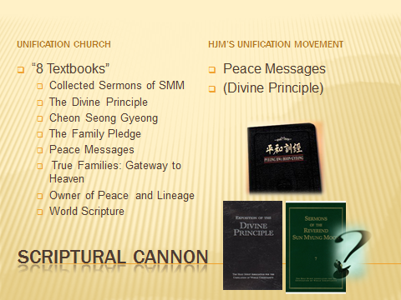
Perhaps paradoxically, the Church side nonetheless possesses a broader canon or scripture than the GPFF side. This is not to say that the GPFF side is more narrow in its outlook toward non-Unificationist religious traditions, but that it officially studies a narrower range of Unificationist scriptures. It particularly stresses the “Peace Messages” of Rev. Moon – public speeches given in the mid 2000s, which are less “particularly Unificationist” than many of his other sermons. The church side, on the other hand, emphasizes the entire “8 Textbooks” which Rev. Moon says he left his followers as his legacy. These include several large compendiums of Rev. Moon’s earlier collected sermons for UC members as well as the Divine Principle text itself. These texts are generally more Christian-based, messianic, and narrow in their soteriological attitude than the Peace Messages. As previously mentioned, Church has also stressed the need for studying and teaching Divine Principle, while UCI and GPFF have downplayed the importance of teaching DP. Finally it should be mentioned that the Church side pays much more attention to the speeches and declarations of Rev. Moon given in the last four to five years, while the Movement side looks upon these speeches with suspicion, as sometimes representing the ideas of Rev. Moon’s manipulative “handlers” more than Rev. Moon’s true legacy.
Sacraments
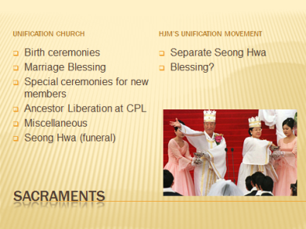
Consistent with its view that “Father did not come to start a new religion,” the GPFF side stresses sacraments less than the Church side. The most important sacrament for the Church, of course, is the Blessing, which is an initiation ceremony that combines marriage, baptism and first communion, as well as the specifically Unificationist idea of the “change of blood lineage.” Other church sacraments include birth ceremonies, the “three-day” sexual initiation ceremony for newly-blessed first generation couples, ancestral liberation ceremonies, the Seong Hwa funeral ceremony and various miscellaneous sacramental traditions. GPFF Unificationists may or may not practice some or all of the above. If the GPFF Movement moves further away from the Church, two important questions will be: will GPFF Unificationists participate in Church “Blessing” ceremonies, and will the Movement develop a separate sacramental tradition for such things as funerals, worship and other traditionally religious functions?
Authority
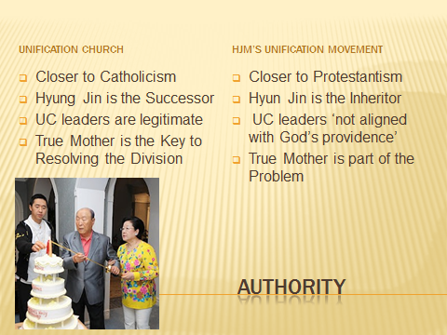
In terms of authority, the Church evidences a more Catholic-type, episcopal, or hierarchical structure. The GPFF faction, while no less authoritarian in leadership style, promotes a more Protestant-type doctrine by emphasizing individual conscience over obedience to the UC hierarchy. As already mentioned, the UC appeals to the primary authority of Mrs. Moon as co-messiah and to the secondary authority of Hyung Jin (Sean) as the messianic couple’s successor. The GPFF accepts the authority of Hyun Jin (Preston) of the inheritor of Rev. Moon’s true legacy. The UC accepts the current UC hierarchy as legitimate. The GPFF view it as corrupt, power-hungry and bogus.
Political Theology
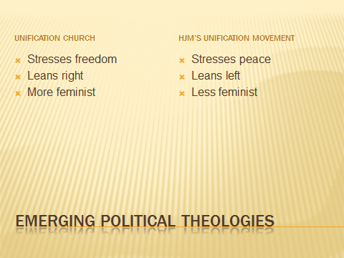
It may be too early to speak with certainty about diverging political theologies, but some preliminary thoughts are still instructive. With its emphasis on Peace, the GPFF is somewhat less hawkish than the Church, which has recently spoken of the need for a Strong Korean alliance with the US and Japan against the growing threat of China. In a very general sense we can also say that the UC leans more right, while the GPFF leans less so. On the UC side, Kook Jin Moon, with his younger brother’s support, has promoted universal gun ownership. The Church has also recently promoted the concept of the “Freedom Society,” a quasi-libertarian vision which argues for small government and individual responsibility, while specifically eschewing theocracy. In terms of feminism—or at least in terms of feminine leadership—the Church has been more overtly accepting of female leaders, especially of Mrs. Moon, while the GPFF has no visible female leaders. Mrs. Moon has often referred to the coming “Age of Women” and the need for the feminine “logic of love” as opposed to the masculine “logic of power” in peace-making. She also serves as the head of the international Women’s Federation for World Peace. Another major female leader on the UC side is Mrs. Hyo Nam Kim, also known as Hoon Mo Nim, who leads the “ancestor liberation providence” at Chung Pyung Lake near Seoul and supervises a major financial operation. The Church, for the past several years, had a strong feminist voice in the Moon’s daughter In Jin, president of the USA church, who gave many sermons with an overtly feminist message.However, this tendency was dealt a serious setback in September 2012 when In Jin resigned in disgrace after it was revealed that she had been carrying on a secret affair with a member of the church’s rock band, from which a love child had resulted.
Heresy and Orthodoxy
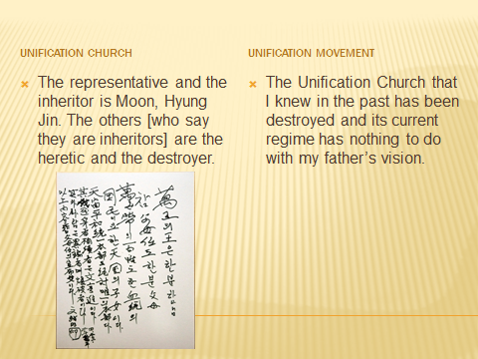
Until recently, the term “heretic” was rarely if ever used by Unificationists. The publication of Rev. Moon’s statement, naming as “heretics and destroyers” anyone who does not accept Hyung Jin (Sean) as Moon’s successor, shows how seriously he himself took the question. The GPFF group took great umbrage at this document, denouncing it as the result of a conspiracy to oust Hyun Jin (Preston) from his rightful position. When the church released a video of Rev. Moon signing the document in the presence of Mrs. Moon and Hyung Jin, opponents replied that this only proved that the clearly aging and uncertain Rev. Moon was being manipulated. Hyun Jin (Preston), meanwhile, clearly sees the UC as completely off track theologically and practically. While not using the term “heresy,” recently he has gone so far as to say that “the UC that I knew in the past has been destroyed and its current regime has nothing to do with my father’s vision.” Clearly, the process of anathematization is already in full swing on both sides.
Providential paradigms
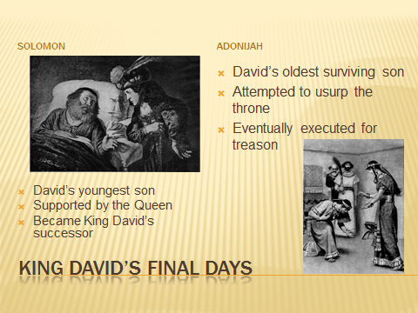
Unificationists often speak in terms of providential parallels, and the current controversy is no exception. For example, the Church officially denounced Hyun Jin as acting as “Fallen Adam” who has been influenced by his father-in-law, Rev. Kwak, to rebel against the divine authority of the True Parents. Two other biblical analogies to the schism have also been particularly mentioned: the succession struggle during the last days of King David, and the relationship between Jacob and Esau.
In King David’s old age, his eldest surviving son, Adonijah, attempted to usurp his throne (1 Kings 1-2). This is seen by supporters for the Church as a providential parallel to Hyun Jin (Preston) rebelling against his Parents’ authority. Just as David and Bathsheba then decided to place their young son Solomon on the throne instead of Adonijah, so Rev. and Mrs. Moon appointed their youngest son Hyung Jin to succeed his father. Solomon went on to become arguably Israel’s greatest king. On the other hand GPFF supporters affirm that the current UC regime has abandoned the principle of the elder son’s inheritance; its corrupt leadership has instead adopted the standard that “Organization is more important than lineage.”

The “Jacob and Esau paradigm” is a particularly popular one. Here, the younger son (Jacob) and his mother (Rebekah) deceived the blind and aging Isaac into blessing Jacob instead of Esau as he had intended. Since the Divine Principle recognizes this as a providentially necessary act, GPFF supporters are reticent to adopt it as an argument in Hyun Jin’s favor. They have, however, argued that the Church must act in accordance with the principle that Jacob demonstrated later, by showing humility and generosity to his older brother rather than actively excluding him. Church supporters counter that the situation is not providentially parallel, because in this case, “Isaac” (Rev. Moon) and “Rebekah” (Mrs. Moon) acted together intentionally to bless the younger son.

GPFF supporters have generally been less prone to adopting arguments based on providential parallels, arguing instead that the providence of restoration is already complete, and the key point now is to “inherit Father’s legacy.”

A Final Word
Before concluding, a word ought to be said about the common ground between the two camps. Although the GPFF side does not mention Rev. Moon’s messiahship publicly, it is a fact that its leadership privately affirms faith in Rev. Moon as the messiah. (Whether it is willing to affirm Mrs. Moon’s co-messiahship is a matter of debate. Reports indicate that Hyun Jin is thoroughly alienated from his mother and blames her for supporting his younger brother. On the other hand, there are also recent rumors of serious disagreements between Kook Jin and Mrs. Moon.) GPFF supporters affirm that they still believe in the Divine Principle and still read Rev. Moon’s internal words privately, even though the Peace Messages are the public focus. They also mention that Hyun Jin starts all internal meetings with a “kyung-be” (obeisance) to True Parents’ picture as well as often reciting the official Family Pledge.
Nearly all Unificationists still hope for reconciliation. However, the schism is undeniably widening and is likely to become more bitter in the upcoming months. A permanent split, of course, would fly in the face of Unificationism’s basic vision, not to mention the Church’s very name. In the meantime, the theological dimensions of the split continue to provide a fascinating study of the impact on schism on the development of theology.
Two thousand years ago, Jesus said, “By this everyone will know that you are my disciples, if you love one another.” (John 13:3) Or, to give the final word to Rev. Moon:
Only love can make two people become one body centering on True Love, father and son, husband and wife, and father and mother can make one body. When brothers unite centering on True Love, they become one body. Only True Love can make unity and oneness. This is not the love of receiving, but the love of giving.

Two objections may be raised here: First, some Unificationists deny that an actual schism exists, seeing the struggle as conflict between faithful followers of Rev. Moon and a few misguided disciples of his wayward son Hyun Jin (Preston). On the other hand, Preston followers insist that the issue is not power, but the true interpretation of Rev. Moon’s legacy.
For a thorough discussion of the “church vs. movement” issues, see David G. Bromley and Alexa Blonner‘s “From the Unification Church to the Unification Movement and Back,” http://www.utsalumni.org/news/from-the-unification-church-to-the-unification-movement-and-back-by-bromley-and-blonner-3598/
The non-UC side, however, rejects the validity of this appointment,
http://www.tparents.org/Moon-Talks/HyungJinMoon-09/HyungJinMoon-090717.htm
http://www.tparents.org/moon-talks/hyunjinmoon/HyunJinMoon-080323.htm
UC supporters may object to be characterized as a “faction.” They see themselves as being the mainstream, orthodox tradition. It is certainly the case that the UC side holds most of the movement’s assets, and commands the allegiance of the vast majority of its followers.
In 1997, Rev. Moon declared “From this day on we are leaving the name ‘Unification Church’ and starting from April 10th you have to use the name of Family Federation for World Peace and Unification.” GPFF supporters insist that this was basically an irreversible decision.
http://www.tparents.org/moon-talks/hyungjinmoon-09/HyungJinMoon-090717a.pdf
http://www.globalpeacefestival.org/mission-and-vision
See FFWP v. UCI. http://www.tparents.org/moon-talks/HyunJinMoon-11/HyunJinMoon-110511.pdf
GPFF supporters claim that Rev. Moon may not have known clearly about the change back to the “Church” brand.
No Unificationist would affirm that Rev. Moon is God Himself, or even ‘God the Son.’ However, the tendency toward divinization is evidenced for example in the idea that Rev. Moon as the True Adam has now become an incarnation or embodiment of God. Recently Rev. Moon had also begun referring to the “God of Day” and the “God of Night” – the former referring to God today, the latter to God before the advent of True Parents. An example of how members respond to this may be seen from church member Andrew Lausberg’s understanding: “In terms of the God of Night and the God of Day, Father is God in the adjectival sense. God is the inner, True Parents now the outer, and both have equal and equivalent value. It does not mean Father is somehow now transformed into the God of Night (the Creator God) but rather that the completion accomplished by True Parents stands on the same level of value as the God of Night, the Creator. Together, they form the God of Night and Day.”
“Nature is the True Church,” http://www.tparents.org/moon-talks/HyunJinMoon-11/HyunJinMoon-110724.htm
See Hyung Jin Moon “Follow True Love (Seven Deaths and Resurrections).” http://www.tparents.org/moon-talks/hyungjinmoon-09/HyungJinMoon-090718.htm
For example, Hyun Jin (Preston) declared: “When I realized that Father was not God, and does not know everything, I respected him all the more.” See “Nature is the True Church,” http://www.tparents.org/moon-talks/HyunJinMoon-11/HyunJinMoon-110724.htm
In terms of traditional Christian soteriology, however, both factions clearly “Pelagian” rather than Augustinian in their theology of grace, as both affirm the crucial role of human responsibility in the process of salvation/restoration.
“Strange Things Are Happening In Our Movement,” http://www.tparents.org/Moon-Talks/hyunjinmoon/HyunJinMoon-100530d.htm
“We Need the Savior,” http://www.tparents.org/moon-talks/hyungjinmoon-10/HyungJinMoon-100612a.htm
Both sides also accept the importance of Rev. Moon’s recent autobiography.
http://www.tparents.org/Moon-Talks/SunMyungMoon10/SunMyungMoon-100708.htm
On the other hand, recent reports from a speaking tour by Hyung Jin (Sean) indicate a commitment to a more congregational-democratic church polity, at least at the local level. Hyung Jin reportedly objected to the characterization that the UC is more “Catholic” in its church governance style than the GPFF movement.
See Tongil Foundation: Chairman Kook Jin Moon Advocates for Defense Buildup in South Korea. http://www.tparents.org/Moon-Talks/KookJinMoon/KookJinMoon-111214.pdf Similar messages have been promoted by both Kook Jin and Hyung Jin Moon in recent public speeches.
It should be noted that a left-leaning tendency within the UC remains visible in such forms as the American Clergy Leadership Council which includes a number of liberal African American pastors. In addition, In Jin Moon made a number of positive comments about President Obama. See for example, “Rev. In Jin Moon’s Speech to ACLC Conference Attendees,” January 30, 2009. http://www.tparents.org/moon-talks/injinmoon-09/InJinMoon-090100.pdf
It should be noted that GPFF’s leader (Hyun Jin – Preston) is also an avid hunter and gun owner.
http://vimeo.com/44905739
Hak Ja Han Moon, “World Peace and the Role of Women.” http://gos.sbc.edu/m/moon2.html
Neither Mrs. Moon’s leadership nor Hoon Mo Nim’s ministry, however, can be seen as “feminist” in the western sense. Hoon Mo Nim’s ministry, which is essentially shamanistic, is in many ways typical of the traditional spiritual role of women in Korea’s male chauvinist society. Mrs. Moon’s authority, meanwhile, derives from that of her husband, although she appears to be emerging now as a leader in her own right.
In Jin often spoke of God’s femininity, refrained from using masculine pronouns to refer to God, and spoke of God as our Parent rather than our Father. She criticized the previous church tradition as “testosterone-driven” and overly militaristic in its style, and looked forward to a leadership style based more on the (feminine) Holy Spirit, in the coming period of Mrs. Moon’s ascendency.
HSA-UWC, September 17 2012: “Important Letter to American Blessed Families: Hyung Jin Moon to take direct leadership in America.” http://www.tparents.org/moon-talks/HyungJinMoon-12/HyungJinMoon-120917.pdf
http://www.tparents.org/Moon-Talks/SunMyungMoon10/SunMyungMoon-100605.htm
See “Revealing the Truth Behind the Heretic-and-Destroyer Declaration.” June 7, 2011. http://howwelldoyouknowyourmoon.tumblr.com/post/6417976877/revealing-the-truth-behind-the-heretic-and-destroyer
“Statement by Dr. Hyun Jin Moon Regarding Unification Church Funeral Service for Rev. Dr. Sun Myung Moon,” September 13, 2012. http://www.hyunjinmoon.com/vision/statement-uc-funeral/
In addition to the “heretic and destroyer” terminology, the Church also engaged in an educational campaign which portrayed Hyun Jin (Preston) as a type of Fallen Adam, under the influence of his Father-in-law Kwak, who has acted as Lucifer. This became widely known throughout the movement as the “Kwak-Is-Satan Tour.” http://www.tparents.org/Library/Unification/Talks/Cotter/Cotter-101104.pdf
See Dan Fefferman, “Open Letter - Hyun Jin Nim, Religious Liberty and Conscience,” June 25, 2010. http://tparents.org/Library/Unification/Talks/Feffermn/Fefferman-100625.htm
See “Revisiting what happened when Hyun Jin Moon visited his father at the hospital.” http://www.tparents.org/moon-talks/HyunJinMoon-12/HyunJinMoon-120920.pdf
See “Rumors About Kook Jin Moon” http://www.tparents.org/Library/Unification/Talks2/Elder/Elder-120924.htm
“True God’s Day,” January 1, 1997

