Esotericism and the Coded Word: Form and Function Without Substance and the Neo-Colonial Political and Social Imperative of Early Mormon Sacred Cryptography
By
Dr. Clyde R. Forsberg Jr.
English and American Studies Department
Aletheia University, Tamsui, Taiwan 251
For
CESNUR 2010 Conference, Torino, Italy
September 9-11

To begin, I want to credit Antoine Faivre and his defense of esotericism as a method that lends itself very well to the study of new religions, in particular those shrouded in mystery, symbolism, ritual, and coded texts--what I shall call, for lack of a better term, the “coded word.” Wouter J. Hanegraaff has identified six distinctive characteristics of all so-called esoteric movements. The first of these, “correspondences,” holds that the universe is a “huge theatre of mirrors, an ensemble of hieroglyphs to be decoded. Everything is a sign; everything conceals and exudes mystery; every object hides a secret.” The focus will be the Mormon case and a most worthy example despite a number of brilliant attempts by historians to relocate the tradition on the side of American evangelical Christianity—past and present. An esoteric approach to Mormon sacred cryptography and the esoteric ritual that it engendered, it is hoped, will begin a more thorough discussion of Mormonism’s esoteric roots, and branches, indeed a study that is not so palpably thesis driven, evangelical, and even neo-colonial in nature. In this respect, Jan Shipps’ iconic Mormonism: The Story of a New Religious Tradition can be seen as the worst offender, again from an esoteric methodological standpoint. Her characterization of Mormonism as an evolution from sect to Church vis-à-vis Ernest Troltsch et al proves problematic. As Hanegraaff explains, “Such ‘interpretations’ descend directly from a discredited 19th-century evolutionism which treated the ‘magical worldview’ of the ‘primitive mind’ as an essentially ‘pre-historical’ syndrome in the literal sense of the word. This approach,” he writes, “is now widely regarded as incorrect with respect to the religions of traditional societies, and is equally unwarranted with respect to our subject.” What follows then is an experiment in esoteric interpretation vis-à-vis Mormonism’s early sacred cryptography, the neo-Masonic or esoteric ritual system it engendered, as well as the neo-colonial political and social agenda contained therein.
Mormonism’s fascination, if not obsession with coded messages can be traced to the very beginning of the movement and founder Joseph Smith’s translation of the golden plates and publication of the Book of Mormon. An inspired project, the translation was nonetheless not possible without the assistance of a measure of esoteric paraphernalia, the Urim and Thummim. Written in “Reformed Egyptian,” the only extant proof of what the hieroglyphics or characters that Smith consulted might have looked light is the famous and still undecipherable “Anthon Transcript,” but a transcript of the one that Martin Harris showed Columbia College Professor Charles Anthon and who later insisted it was a kind of Near Eastern alphabet soup having no real rhyme or reason that he could detect except perhaps to defraud Harris and others.

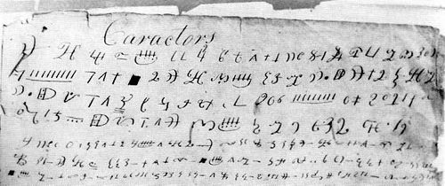
Figure 1: “Anthon Transcript” in the Possession of David Whitmer (1887)

The historiography of the Anthon Transcript is almost more interesting than the actual document itself. A wide array of linguistic parallels has been cited: Hieratic, Demotic, Coptic, Hebrew, Mayan/Olmec, and even Gregg’s Shorthand. Moreover, at least two esoteric translations have been put forward and said to correspond perfectly with different sections of the Book of Mormon.
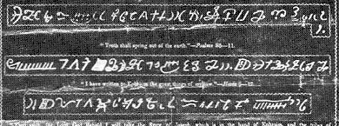
Figure 2: Book of Mormon Broadside and Hieroglyphs

The problem of how to read and interpret these and other examples of Mormon sacred cryptography has yet to be explored in any systematic way vis-à-vis the various esoteric and Masonic crypto-logical options available to the Mormon Prophet and others at the time. Brigham Young and Oliver Huntington, for example, were both versed in Masonic cryptography as their journal entries attest. Templars had a cipher, too, many in fact and herein lies the problem, for one is faced with a dizzying array of competing fraternal cryptographies from which to choose. Moreover, the invention of “Deseret,” a Mormon phonetic alphabet and cipher that enjoyed a brief shelf life in pioneer Utah under Young suggests that any search for a direct correlation between Mormon and Masonic cryptograms may well be a fool’s errand. That said, the 20-cent Deseret coin minted in honor of this uniquely Mormon cipher includes such Masonic images as the all-seeing eye and clasped hands, as well as the motto of Royal Arch Masonry—Holiness to the Lord—written as it were in code. One New York Times reviewer observed that its characters were an odd combination of Celtic rune and Pitman shorthand, suggesting a racial or Celtic Anglo-Saxon agenda.
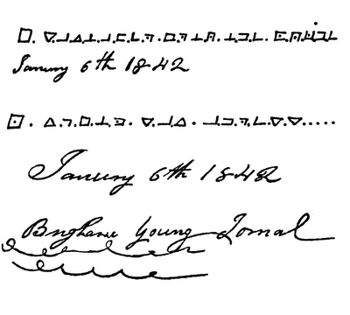
Figure 3: Royal Arch Cypher in Brigham Young’s Journal (6 Jan. 1842)

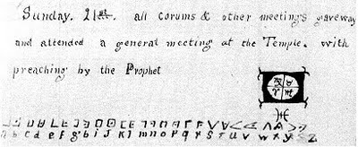
Figure 4: Royal Arch Cypher in Oliver Huntington’s Journal (21 Jan. 1844)
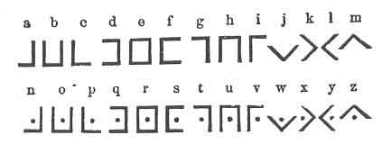
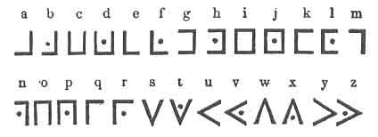
Figure 5: The Two (2) Royal Arch Cyphers. In Duncan’s Masonic Ritual and Monitor (1866), p. 248
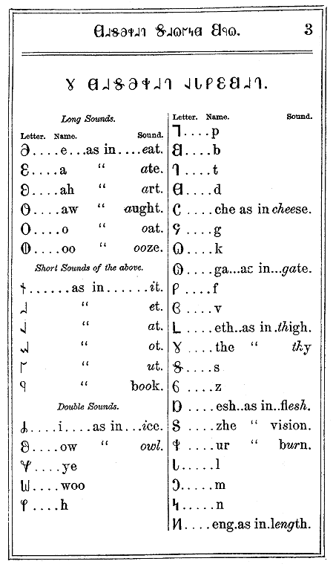
Figure 6: Deseret Alphabet, Book 2 (1854-1877)

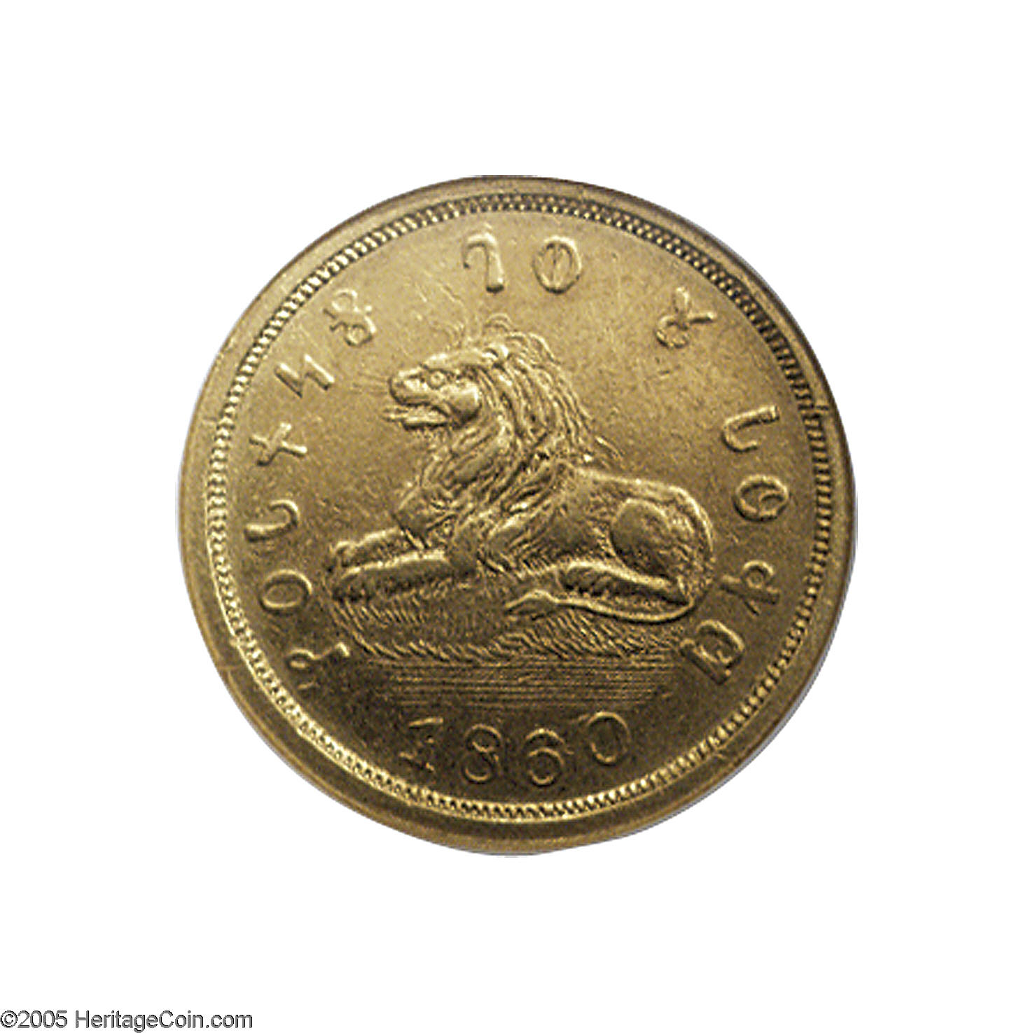

Figure 7: Deseret Gold Coin and Royal Arch Motto “Holiness to the Lord”

However, the story does not end with Masonic cryptanalysis, for there are also a goodly number of magical alphabets or ciphers that dare not be ignored and associated with such luminaries of European renaissance occult science as Henrich Cornelius Agrippa and Johannes Trithemius. In addition, numerous hieroglyphs for the planets beg to be included and which Agrippa also catalogues. John Dee and Edward Kelly constitute yet another font of endless esoteric crypto logical preservation and invention. Much of this esoterica was available to Smith in popular 19th century English works like Francis Barrett’s The Magus (London, 1801).

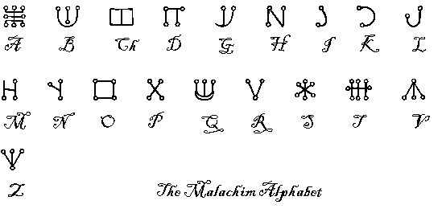
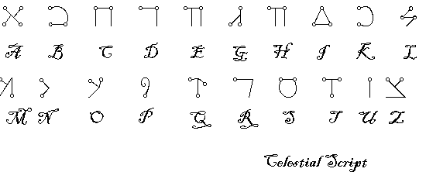
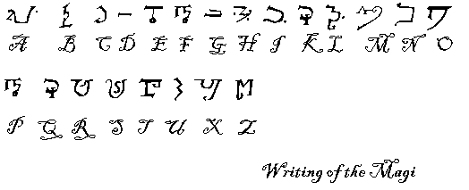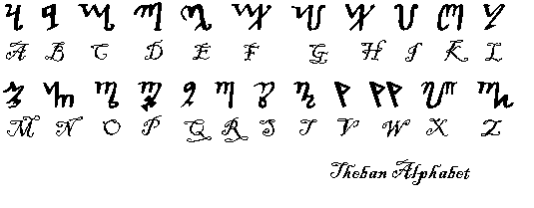
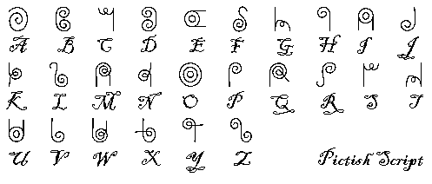
Figure 8: The Varieties of Magical or Angelic Writing





Figure 9: Characters for the Seven Planets: Saturn, Jupiter, Mars, Sun, Venus, Mercury, and the Moon (from top to bottom)

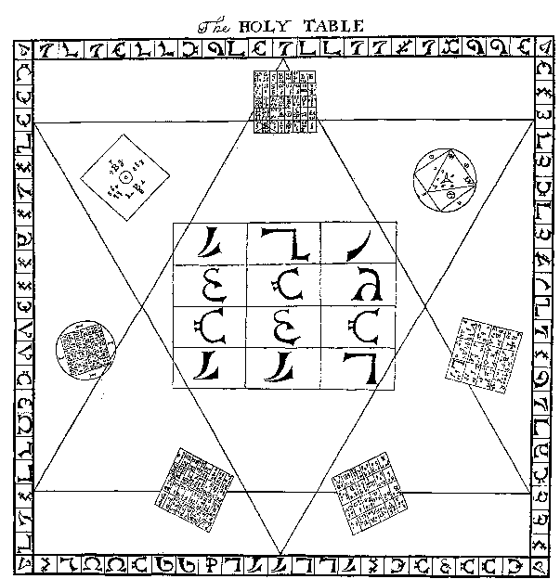Figure 10: The Holy Table. In Meric Casaubon's A True and Faithful Relation of What Passed Between John Dee and Some Spirits (London: T. Garthwait, 1659), p. 72
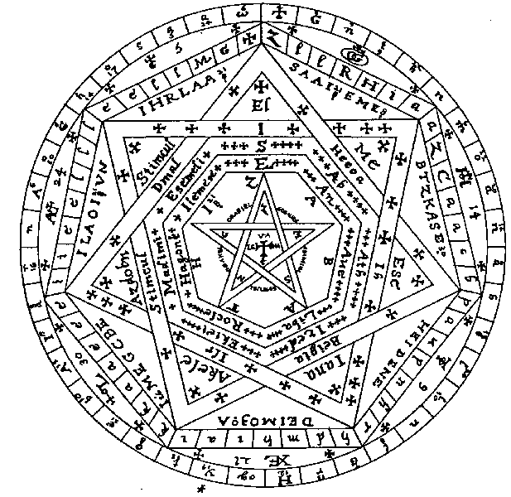
Figure 11: In Mysteriorum Libri Quinque or, Five Books of Mystical Exercises of Dr. John Dee: An Angelic Revelation of Kabbalistic Magic and other Mysteries Occult and Divine revealed to Dr. John Dee and Edward Kelly, A.D. 1581 – 1583,
Ed. Joseph Peterson (Wales: Magnum Opus Hermetic Sourceworks, 1985), Book II, Chapter 11.
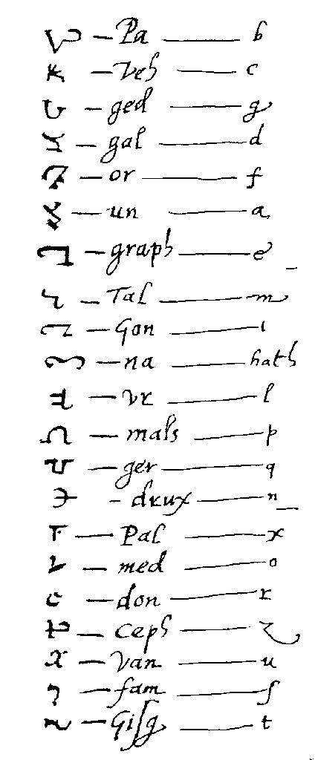
Figure 12: John Dee’s “Enochian Alphabet” in Ibid.
Finally, and returning to the curious characters that were used to advertise the Book of Mormon, if Hebrew in derivation (though much of the magical orthography is too) then it may be important to note that in my own cursory analysis there is a preponderance of Rabbinic Hebrew characters and easily mistaken (and perhaps intentionally so) for Egyptian cursive, that is, Hieratic and Demotic in particular. A number of Samaritan characters are there and consistent with the Masonic reverence for and employment of Samaritan ciphers. As Albert G. Mackey explains in his Encyclopedia of Freemasonry:
It is believed by Scholars that, previous to the captivity, the alphabet now called the Samaritan was employed by the Jews in transcribing the copies of the law, and that it was not until their return from Babylon that they adopted, instead of their ancient characters, the Chaldee or square letters, now called the Hebrew, in which the sacred text, as restored by Ezra, was written. Hence, in some rituals, especially those used in the United States, the Samaritan characters find use.
E. Smith’s 1814 work of Near Eastern comparative philology, entitled A Vocabulary, Hebrew, Arabic, and Persian contains the necessary basic information for anyone interested in adapting Samaritan to their own esoteric and ritualistic purposes—Masons and/or Mormons.
At the same time, grammars and vocabularies of Demotic also in circulation as early Mormonism began to take shape suggest that the so-called Book of Mormon characters may indeed be Egyptian in derivation. Thomas Young’s 1815 work on Demotic is worth noting, many of the characters in a catalogue of his works and essays published in 1831 bear a striking resemblance to those of the Anthon Transcript and broadside already mentioned. Characters that are neither Hebrew nor Samaritan, for example, do appear to be Demotic at least in form, but are numbers and months of the year, if Egyptian. Their significance or meaning is unclear at best. Of course, the other Egyptian source text and authority on all things Egyptian and esoteric prior to Champollion was Athanasius Kircher’s magnum opus Oedipus Aegyptiacus: Sigillum Aemeth (Rome, 1652-4) and about which more will be said later in this essay.
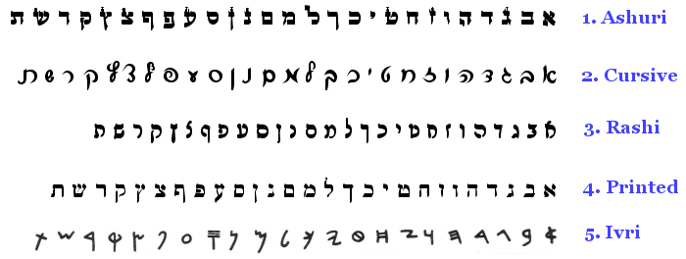
Figure 13: Variety of Hebrew Square and Cursive Scripts
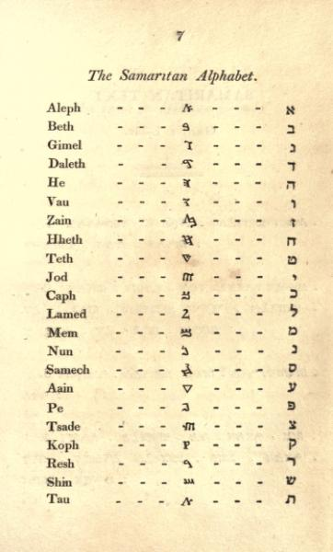
Figure 14: The Samaritan Alphabet. E. Smith’s A Vocabulary, Hebrew, Arabic, and Persian (1814)
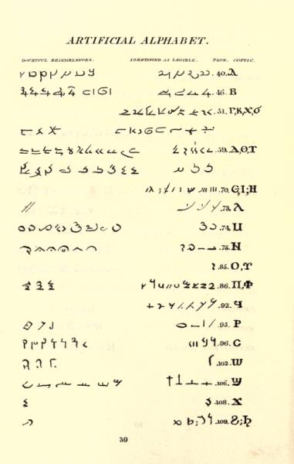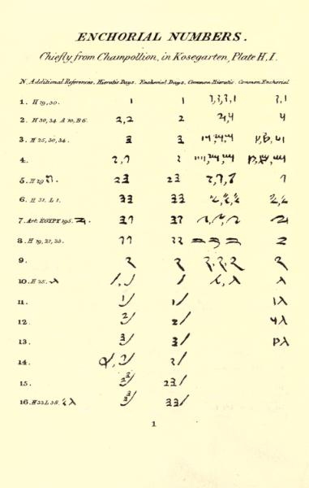
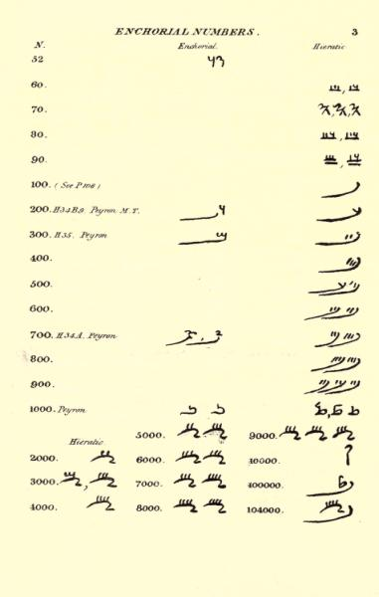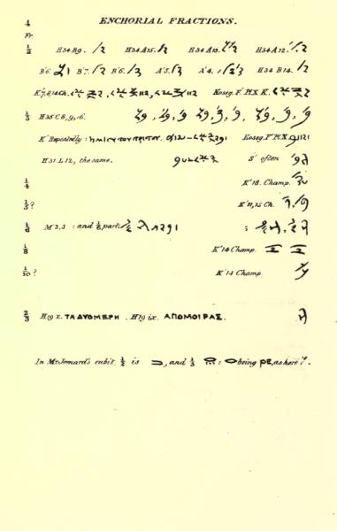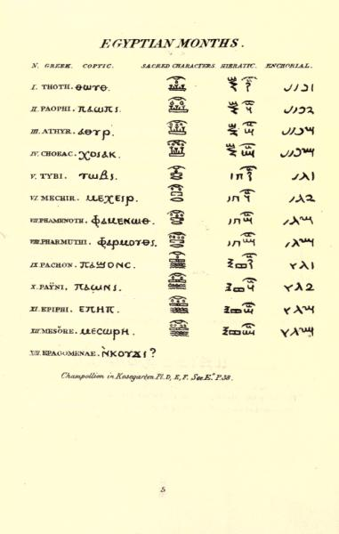
Figure 15: Demotic Alphabet, Numbers, and Months. In A Memoir of the Life of Thomas Young (1831)
To be clear, my interest is more in the form and function rather than substance of such early Mormon cryptograms, their translation pretty much anyone’s guess. In fact, any attempt to unravel their substance misses the point, for the objective is to obfuscate, constituting a brilliant defense strategy and certain to confound the wisdom of the world and thus bolster faith. At least, this is certain the Mormon case. But there is a positive function in all of this, as I will also show, that is both political and social in nature. Ironically, this is due in part to the refusal of secular scholarship to employ an esoteric approach in its analysis of hermetic traditions like Mormonism, steering clear of the coded word as a matter of professional courtesy. Part of the problem is an unwillingness to acknowledge that Mormonism and Masonry constitute two competing esoteric traditions in the antebellum American hothouse with a similar reverence for the coded word, and so Mormonism’s cultured defenders would do well to consider how Masonic cryptanalysis works and to what degree it applies to the Book of Mormon and another LDS foundation texts of equal importance and controversy, the Book of Abraham.
The historical convention these days is to recount the Mormon story as a bi-product of evangelical revivalism and anti-Masonry, Smith torn between his father’s deism, his mother’s Presbyterianism, and a penchant for Methodism (frontier revivalism) however fleeting it may have been. In fact, the real story as told by Smith is somewhat different, the boy prophet confined to his room and pouring over his Bible in quiet seclusion as an antebellum American apprentice of Masonry might. Most of the time, we find him digging for buried treasure by day and recounting in remarkable detail and long before the Book of Mormon the exploits of America’s original inhabitants. At a pivotal point in his religious life, Smith is visited by an angel and directed to the secret location of a lost American history inscribed on golden plates which he alone will bring to the attention of a somewhat skeptical evangelical public. About the same time he began the arduous task of translating the golden plates, and whether real or imaginary matters little in hindsight, another New Yorker and Mason, Robert B. Folger, sat down to compose an apology for Masonry entirely his own as well. Importantly, the cipher he created had an unmistakable Egyptian quality. Being a Mason, this makes sense given the reference for Egypt in fraternal lore. The nine most frequent ciphers that he employed can be found in the Mormon ciphers discussed thus far, too. As Scottish Rite historian S. Brent Morris explains:
Folger’s alphabet is unlike any other Masonic cipher, even though several of his symbols can be found in some hauts grades ciphers. This, however, is not surprising because of the small possible number of simple geometric shapes. It is most likely that he invented his system on his own, with inspiration from some other Masonic book or manuscript. However, his technique of stacking his symbols is unique to him and greatly increases the cryptographic security of the system. Based on the mixture of good and bad cryptographic practices and on the evolving nature of the cipher through the manuscript, it can be concluded that Folger was a self-taught amateur who invented a rather good cipher.
Remarkably, Masonic cryptanalysts broke the cipher and so a complete translation is now available.
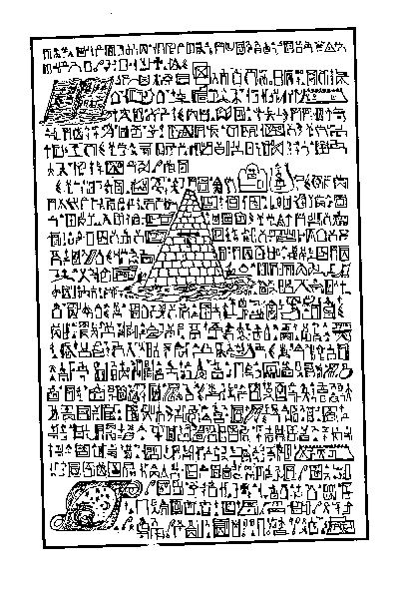
Figure 16: Page from the So-Called “Folger Manuscript”
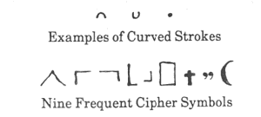
Figure 17: Some of Folger’s Repeating Ciphers
Folger was no ordinary Mason, in fact, but something of an iconoclast—so much so that he was expelled from the order for his heretical beliefs not once but twice. A desire to graft Scottish Rite Masonry to the trunk of Christian Masonry or the Knights Templar proved problematic for many within the brotherhood. In Committed to the Flames: The History and Rituals of a Secret Masonic Rite, Arturo De Hoyos and S Brent Morris provide a near complete translation of his writings, pointing out that his penchant for the coded word was a corollary of his desire to see the "Rectified Scottish Rite" (a European offshoot of the Rite of Strict Observance and type of Christian Masonry) take root in America. His coded writing includes some of the earliest and most complete transcriptions of the Scottish and Egyptian Rite, as well as the American Order of the Red Cross and Knights Templar degrees. He employed Hebrew characters in places. And not unlike the Mormon prophet, he penned a volume that claimed to be “of great antiquity, [the] splendid monuments of the ancients,” he goes on to say, having “decayed and nations who peopled the countries where these things were written have vanished or are scattered over the face of the earth, their former places of abode are desolate, the languages the book was written in are dead, yet the book survives.”
A work intended for fellow Masons, why did Folger employ a cipher entirely his own? One might well ask the same question of the Mormon prophet, publishing a radical new Masonic monitor of his own with its fair share of Masonic coded language. Moreover, it did not stop with the Book of Mormon. To answer the question posed As Morris rightly points out; Masonic cryptography is not about secrecy per se, but the symbolism of secrecy. And so, the Reformed Egyptian of the Book of Mormon, the Book of Mormon characters, and the Egyptian per se that gave us the Book of Abraham all gave the impression of something ancient and thus mysterious and authoritative, consistent with a particular political and social agenda and power structure.
The Cryptography of the Book of Abraham
Only forty-three days before the Mormon prophet and presidential hopeful Joseph Smith Jr. would be shot to death by a mob in Carthage, Illinois, he made the acquaintance of Charles Francis Adams (son of the former President) and Josiah Quincy. Adams was a member of the Massachusetts House of Representatives and would go on to make a name for himself as a Boston, anti-slavery Whig, and Free-Soil candidate for Vice President, and then as Abraham Lincoln’s Minister to England. Quincy was a year from succeeding his father as Boston’s preordained mayor in the Quincy tradition. What possessed these “Boston Brahmins” to make the trek to the Mormon capitol, Nauvoo, Illinois, in 1844 is hard to say. Whether they came to praise Caesar or bury him is not altogether that clear either. Smith did not disappoint, and Quincy later wrote about the encounter in somewhat glowing terms in an 1883 work, entitled Figures of the Past:
It is by no means improbable that some future text-book, for the use of generations of yet unborn, will contain a question something like this: What historical American of the nineteenth century has exerted the most powerful influence upon the destinies of his countrymen? And it is by no means impossible that the answer to the interrogatory may be thus written: Joseph Smith, the Mormon Prophet. [Italics in original.] And the reply, absurd as it doubtless seems to most men now living, may be an obvious commonplace of their descendants. History deals in surprises and paradoxes quite as startling as this. The man who established a religion in this age of free debate, who was and is to-day accepted by hundreds of thousands as a direct emissary from the Most High--such a rare human being is not to be disposed of by pelting his memory with unsavory epithets. Fanatic, impostor, charlatan, he may have been; but these hard names furnish no solution to the problem he presents to us.
What follows contains more than a hint of sarcasm. Apparently, when he and Adams arrived in Nauvoo, there was some confusion over their true identity, some presuming that the ex-President, John Quincy Adams, rather than Charles Francis Adams and Josiah Quincy, had come to see the Prophet. “The prophet’s own chariot,” Quincy writes, “soon made its appearance” (p.133). “Happily,” he explains, “Dr. Goforth divided our persons and reduced them to their proper proportions, so that no trace of disappointment was visible in the group of rough-looking Mormons who awaited our descent at the door of the tavern” (p. 133). His description of the Prophet is less than flattering: “a man of commanding appearance, clad in the costume of a journeyman carpenter . . . a hearty, athletic fellow, with blue eyes standing prominently out upon his light complexion, a long nose, and a retreating forehead.” The rest is rather unkind, too, Smith’s work clothes allegedly that of a court jester or circus clown--although Quincy does not come out and say so: “striped pantaloons, a linen jacket, which had not lately seen the washtub, and a beard of some three days growth.” Apparently, Smith put on airs, “as a crowned head might adopt on receiving the heir presumptive of a friendly court . . . that sort of cordiality with which the president of a college might welcome a deserving janitor” (p. 133). This was followed by a display of Smith’s “miraculous gift of understanding all languages, [taking] down a Bible in various tongues, for the purpose of exhibiting his accomplishments in this particular,” and then a visit to the basement where the Prophet’s mother and a private collection of Egyptian antiquities awaited their inspection.
Judging from Quincy’s description, the whole event lacked dignity. That Smith alleged the papyri to be the lost writings of Abraham, Moses, and Aaron did not help matters. “This is my mother, gentlemen. The curiosities we shall see belong to her. They were purchased with her own money, at a cost of six thousand dollars” (p. 136). Quincy recalls being taken aback by “a rude drawing of a man and woman, and a serpent walking upon a pair of legs. I ventured to doubt the propriety, of providing the reptile in question with this unusual means of locomotion.” And Smith’s response proved less than satisfactory: “Why that’s as plain as a pikestaff. . . . Before the Fall snakes went about on legs, just like chickens. They were deprived of them, in punishment for their agency in the ruin of man” (p. 137). Quincy went away more skeptical than ever, detecting “no holier spirit than that of commerce,” in part because of what happened as they were about to leave when the Prophet stopped them and said: “Gentlemen . . . those who see these curiosities generally pay my mother a quarter of a dollar” (p. 137).
The story of the Book of Abraham, how it came into existence, and how it would go on to change the course of Mormon history and theology has yet to receive the attention it deserves. The book is best known as a dark page in the Latter-day Saint canon and as the scriptural basis for the practice of denying the Priesthood to Blacks because of an alleged genealogical connection to Cain through Canaan the son of Ham. Moreover, other revelations and books of scripture that Smith received around this time--an inspired revision of the Bible from which the Book of Moses is taken--retell the story of Cain as an apostate Mason ordained by none other than Satan himself and Grand Master after a fashion. The so-called “curiosities” that gave us the Book of Abraham tarred Egypt and thus Africa with the same pro-Masonic/anti-Masonic brush--a cursed bloodline and apostate Priesthood or clandestine Masonic order.
The Book of Abraham became the basis for a new understanding of the political kingdom (Priesthood) and race. In the original or Book of Mormon formulation, one’s race is decided according to one’s faith or lack thereof. A dark skin follows rather than precedes disbelief. The wicked, dark-skinned Anti-Nephi-Lehis, for example, repent of their sins, mix with their brothers the (white) Nephites, and become white thereafter. In the Book of Abraham, on the other hand, belief will not undo or overcome the problem of race. In the evolution of the Mormon understanding of race, the question is not so much a connection to the Priesthood, but whether one drop of African blood automatically and forever disqualifies one from full fellowship, that is, to go through the temple and receive the saving ordinances and endowments or the Priesthood. The important question, then, is what gave impetus to such a radical change in attitude.
Joseph Smith’s Emblematic Reading of Egyptian Funeral Texts
Another important difference between the Book of Mormon and Book of Abraham that should not be overlooked pits one against the other as supernatural and natural in origin respectively. Smith translated the Book of Mormon with the aid of a set of magical reading glasses (Urim and Thummim) that came with the golden plates,
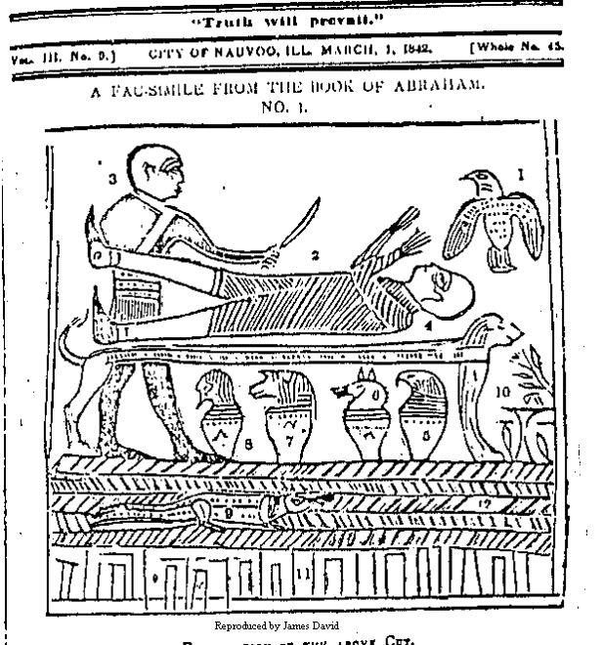
Figure 18: Book of Abraham Facsimile No. 1
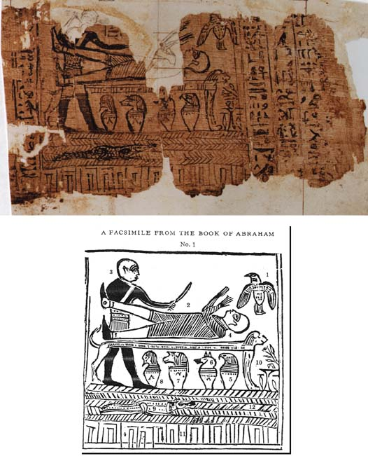

Figure 19: Original Sen Sen Text or Book of Breathings
both of which he returned to the safe keeping of the angel Moroni, his spirit guide, mentor, and last of the Nephite prophets and authors of the volume. Smith’s translation of the Book of Abraham, by contrast, was a quasi- or pseudo-academic affair from beginning to end, requiring the services of an Egyptian grammar, albeit of his own esoteric making and design. For this reason perhaps, the Book of Abraham does not have the ring of revelation, at least not as Northrop Frye understands revelation, for it is all too scholarly and author-centered to qualify as a divine revelation on par with the Bible.
Ironically, for Mormon apologist Terryl Givens, in his book By the Hand of Mormon: The American Scripture that Launched a New World Religion, it is the Bible that does not qualify in some respects as a revelation on par with the Book of Mormon. The Book of Mormon and the Bible are profoundly different and, therefore, “any attempt to find middle ground by analogizing the Book of Mormon and the Bible that does not take cognizance of this fundamental and irreducible difference . . . may be an exercise in futility.” Mark Thomas’ critical analysis of the Book of Mormon, Digging in Cumorah: Reclaiming Book of Mormon Narratives, and indeed any and all such attempts to get to the bottom of the message of the book do not seem to understand that the medium is the message. “Here the nature of revelation,” Givens argues, “is not so important as is its sufficiency.” That said, Frye’s contention that “the great religious teachers do not write: they talk, and their words are recorded by secretaries or disciples” bodes well for the Book of Mormon, the real question not the difference between the Bible and Book of Mormon, but between the latter and the Book of Abraham.
Whether Smith could read Egyptian misses the point, the more important question being, how he read the hieroglyphs and what this might tell us about his conservative political and radical social agenda. (One should not forget that almost no one in the academy fared much better, the idea that Egyptian was symbolic in the main very much in vogue.) In some respects, Hugh Nibley’s defense of the Book of Abraham as a work of “vertical” translation--the papyri containing a hidden message that only Smith could discern and thus the trans-textual basis for the Book of Abraham--addresses the real issue of how. Givens’ post-modernist defense of the Book of Mormon as similar in kind--a vertical translation of the golden plates--might be said to take its cue from Nibley’s defense of the Book of Abraham. When Smith sat down to translate the Egyptian texts in his possession and the property of his mother, he did so as any early nineteenth-century Egyptologist might. In 1835 when work on the Egyptian papyri began (purchased from the Philadelphia dealer in antiquities Michael Chandler), Smith was a student of classical Hebrew, the allegorical or so-called “emblematic” method, and, as such, an Egyptologist of promise, assuming the mood of the academy did not change. Of course, it did, and rather dramatically; and herein lies the problem.
Had it not been for the discovery of the Rosetta Stone (and not until 1799), furnishing Egyptologists with the first Greek interlinear translation of Egyptian, the allegorical or so-called “emblematic” method might still be in vogue. Erik Iversen, in his book The Myth of Egypt and its Hieroglyphs in European Tradition, has shown that countless medieval and renaissance allegorical or emblematic translations of Egyptian had the blessing of the academy, translations that were no more faithful to the original texts than, in this case, Joseph Smith’s translation of the Book of Abraham. He makes the important point, too, that a useful Egyptian publication based on Champollion’s work would not be completed until 1872, and that the French pioneer and father of modern Egyptology who died in 1832 at the age of 42, was submitted “to the disgraceful ordeal and mock-trial of envy, ignorance and stupidity” (p. 146). Champollion’s was a valiant attempt to offer up a more sure word of prophecy linguistically speaking, an approach to Middle Egyptian that was scientific and thus horizontal, which then threatened to undo (indeed unmask) centuries of so-called scholarship. Many were inventive Platonic and Neo-Platonic apologies for Christianity and thus a search for some Osiris-Christian connection; many believed that Egyptian texts should be seen as a divine (Christian) revelation in themselves. The idea that Egypt had a hidden Christian agenda was the inspiration for such ideas as the death and resurrection of Osiris as a type of Christ, Hermes Trismegistus a contemporary and convert of Moses, and the pyramids as symbolic representations of the granaries of Joseph (p. 68a.). The works of the fifth-century Coptic Christian and practitioner of the allegorical method, Horapollo Nilos, would be republished by Alexander Turner Cory of Cambridge in 1840 as The Hieroglypics of Horapollo Nilos.
That Smith thought the papyri were the handiwork of Moses as well as Abraham is consistent with another idea common to this school of emblematic translation that also traces it origins to Johan Reuchlin no less (the famous renaissance humanist and German Bible translator) and who thought Moses was the font of hermetic wisdom in Egypt and not the pagan, Hermes Trismegistus. That Moses and thus Egypt knew of the coming of Jesus Christ follows from this, the Egyptian origins of Christianity a great mystery to be solved by reading between the lines. As Iversen explains:
But it is strange to see how, contrary to his intentions and his thesis, his influence furthered the growing speculation about an idealized Egypt, the original home of all mystic and occult knowledge, and it is a curious fact that the myth about the wisdom of Egypt flourished especially in those circles in which Reuchlin’s influence was greatest: among the various occult sects and societies of the seventeenth and eighteenth centuries, among Freemasons and Rosicrucians, and among modern theosophists as well (p. 77).
Translation of ancient Egyptian, according to Reuchlin, was a quest for the hidden, Christian message behind the hieroglyphs. The whipping boy of Egyptology, the German-born Jesuit, Athanasius Kircher, is best known in this regard, his allegorical virtuosity legendary. As Iversen explains, Kircher rallied the wisdom of no less than “the totality of human knowledge, in religion, philosophy, history, and science,” to create “a theological system, [and] a universal cosmology, based on the concepts and ideas of a Neo-Platonized Christianity” (p. 94).
Erik Hornung’s The Secret Lore of Egypt: Its Impact on the West sheds considerable additional light on the question of Smith as a translator of ancient Egyptian in the renaissance occult sense and typical of “Egyptosophy,” which is notorious for “making highly ‘scientific’ demonstrations that the scientific discipline of Egyptology is wrong.” Hornung admits that “it is futile to prove or disprove esoteric truths that are nourished solely by revelation, faith, and displays of intuition” (p. 3). Importantly, such an approach as well as the fascination with Egypt for Kircher and possibly for the Mormon Prophet, too, had a political dimension. Kircher’s Egyptososphy was a thinly veiled defense of the Catholic Counter-Reformation, Smith’s part and parcel of an increasingly vitriolic, anti-Evangelical agenda and, as I will attempt to show, also in defense of monarchy. Kircher, like Smith, filled in the blanks, restoring “missing portions of obelisks and the like,” Hornung explains, and even drafting “new hieroglyphic inscriptions . . . a confused mixture of ancient Egyptian sign forms and others of his own devising” (p. 101). Ralph Cudsworth and other disciples of Kircher carried on in the tradition of emblematic translation of Egyptian texts as a new textual and scriptural basis for political reform (p. 103).
The proponents of Egyptosophy such as Rosicrucians identified so closely with Egypt, in part, because it conformed so well to their monarchical and neo-medieval hopes for the present and future. Their admiration for Trismegistus, the titular head of the occult, was as a “king, lawgiver, philosopher, and priest” all rolled in one--the supreme example of supreme religious and political power (p. 111). Rosicrucianism, coming to America in the late 1600s, rejected not only the rationalism inherent to the Enlightenment but its latent republicanism. Robert Fludd (1574 - 1637) and Elias Ashmole (1617 - 1637) of the Rosicrucian Enlightenment are said to be forerunners of English Freemasonry which, in turn, may account for Craft Masonry’s hierarchical leanings. James Anderson’s “Constitutions of the Freemasons” printed in 1723 by a London publisher, traced the order back to Egypt via Noah’s grandson, Mizraim, who brought it there following the flood and where Moses is said to have been a Grand Master.

Modern Egyptology and Early Anti-Mormon Polemic and Pro-Mormon Apologetic
Much of this has been lost on scholars who criticize the Book of Abraham for not being a translation in the modern, scientific, horizontal-linear sense. In 1912, a Protestant minister from Utah published an anti-Mormon tract, entitled “Joseph Smith, Jr. as a Translator,” cataloguing the criticisms of leading Egyptologists at that time--A. H. Sayce of Oxford, Flinders Petrie of London University, James Breasted of the University of Chicago, Arthur C. Mace of the Metropolitan Museum of Art, John Peters of the University of Pennsylvania, Edward Meyer of the University of Berlin, and Friedrich Freiheer Von Bissing of the University of Munich. In addition to the translation, the Book of Abraham includes three so-called facsimiles of the Egyptian papyri. The originals were thought to have been lost forever in a museum fire, but the facsimiles provided more than enough rope to hang Smith out to dry.

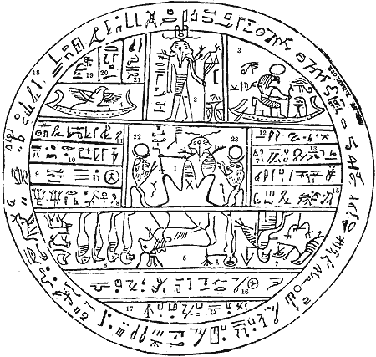
Figure 20: Book of Abraham Facsimile No. 2

This distinguished group of scholars agreed that Smith had mistaken a common Egyptian funeral text as the last word on Abraham. However, they could not quite agree on how to read the bulk of the texts the question--and that is a little revealing. For example, they failed to agree on the identity of the figure pictured on a lion couch in facsimile No. 1. He is not Abraham as Smith thought. Bissing and Meyer thought it might be the corpse of some anonymous Egyptian, whereas Breasted and Petrie assumed it must be Osiris. No consensus had been reached on the true identity of the bird pictured to the right: Peters, Meyer and Bissing thought it symbolized the soul of the dead man, Petrie, the hawk of Horus, and Breasted, Isis. The figure standing upright proved equally enigmatic. Meyer and Breasted actually agreed with the Mormon Prophet, that it might be a priest of some Egyptian order, Peters, an embalmer, and Petrie, none other than Anubis. If the idea was to completely embarrass, an obvious failure to agree on the essentials undermined the entire project in some respects. Samuel A. B. Mercer as author/editor of this anti-Mormon broadside was reduced to arguing that bona fide Egyptologists had failed to arrive at a clear consensus because, alas, Egyptian funeral texts were open to more than one interpretation—excluding Smith’s mystical interpretation, of course. Indeed, Bissing had been professional enough to acknowledge that Smith “probably used Anthenasius Kirsher [sic] the Jesuit’s work, and there found a method of reading the old Egyptian signs very much like his own” (p. 31).
Mercer, no feather-weight himself as Professor of Hebrew and Old Testament at Western Theological Seminary in Chicago, made a great deal, too, of a stock of common Hebrew words that seemed to masquerade as Egyptian in the Book of Abraham. Mercer accused Smith of being a poor scholar of Hebrew for having misspelling many of the Hebrew words in question. However, Mercer did not stop to consider how the Mormon Prophet’s unorthodox transliterating was simply Sephardic and thus Rabbinic in nature and origin, his Hebrew teacher none other than Joshua Seixas, the Ohio preacher and Hebrew scholar of Portuguese-Jewish ancestry. As Louis C. Zucker, Professor Emeritus of English and Hebrew at the University of Utah and member of the B’nai Israel, has shown, Smith “translated virtually in the Seixas way.” Smith’s translation of the Book of Abraham was inspired, in part, by his study of Hebrew under Seixas (1835 - 1836) and who seemed to approve. “Mr. Seixas, our Hebrew teacher,” Smith writes in his journal “examined the record, and pronounced it to be original beyond all doubt” (cited in Ibid, p. 50).
Seixas was a convert to Christianity, his uncle a Grand Master of some prominence, too. Martin A. Cohen explains in Sephardim in the Americas: Studies in Culture and History that this fascinating specimen of antebellum American Judaica was a curious mixture of expatriate Iberian-Christian converts to Judaism, Iberian Jews proper, and Iberian Christians of Spanish and Portuguese descent often accused of being “secret Jews.” The tradition itself is decidedly mystical and even messianic. The infamous messianic pretender who converted to Islam, Shabbatai Zevi, was of Sephardic extraction and sensibility, for example (p. 63). Smith may have thought he had a potential convert in Seixas, whereas Seixas fulfilled his contractual obligations and bid the Saints adieu. Whether Seixas was a “crypto-Jew” seems unlikely, and if anything, Mormonism’s revisionist Masonic agenda may explain his reluctance to make Mormonism his new religious home.
The problem of the Book of Abraham as a translation of Egyptian funeral texts would be revisited in the late 1960s when the original papyri were discovered in toto, making it possible to adjudicate on the matter of Smith’s powers of translation once and for all. Professor Klaus Baer of the University of Chicago’s Oriental Institute would publish his findings in a landmark article in Dialogue: A Journal of Mormon Thought, entitled “The Breathing Permit of Hor: A Translation of the Apparent Source of the Book of Abraham.” Not surprisingly, Baer failed to discover anything to suggest that Smith had translated the papyri in any conventional sense, and to which Nibley valiantly, and brilliantly, responded. Attempting at first to create as much distance as possible between the papyri and the Book of Abraham, Nibley argued that Baer’s modern translation and Smith’s mystical interpretation were both faithful translations in their own right.
A classic and model of modern, Mormon apologia, Nibley’s The Message of the Joseph Smith Papyri criticized Baer for failing to consider a number of “obvious and unavoidable questions. . . . How on earth could Joseph Smith or anybody else,” for example, “have derived a condensed and detailed account of fifty pages from less than twenty hieratic signs? How could such signs have suggested a history, let alone contain it? Why must a hard-working author derive his whole book from less than two dozen signs, when thousands were at his disposal?” Just to be safe, Nibley also insisted that the Egyptian papyri Smith had consulted were still missing, in effect:
Is the Book of Abraham a correct translation of Joseph Smith Papyri X and XI? No, the Book of Breathings is not the Book of Abraham [italics in original]. Does it pretend to be? No, it was never put forward as such. . . . But didn’t Joseph Smith think [italics in original] he was translating the Book of Abraham from those papyri? . . . He might have wanted to fool people into thinking that he had translated it from these particular papyri, but if so, why did he never put forth such a proposition? . . . Whatever exercises, discreet or indiscreet, the brethren in Kirtland may have been engaged in, the Prophet Joseph himself has supplied us with the most conclusive proof that the manuscript today identified as the Book of Breathings, J.S. Papyri X and XI, was not in his opinion the source of the Book of Abraham. . . . “The record of Abraham and Joseph, found with the mummies, is (1) beautifully written on papyrus, with black, and (2) a small part red, ink or paint, (3) in perfect preservation” (p. 2).
Nibley also claimed the three facsimiles had texts of no real relevance and typical of many such funeral scenes and their texts. “For a demonstration of the strange practice of putting the illustrations of one story with the text of another, we need look no further than the Joseph Smith Book of Breathings itself, where the scene depicted so vividly in the Facsimile is nowhere mentioned in the text that immediately follows” (p. 3). And so, he concluded that,
Joseph Smith actually possessed quite a number of perfectly preserved, beautifully written Egyptian manuscripts adorned with rubrics . . . there can be no doubt whatever that the manuscript he was describing was and is an entirely different one from that badly written, poorly preserved little text, entirely devoid of rubrics, which is today identified as the Book of Breathings” (p. 3).
Indeed, Nibley’s The Message of the Joseph Smith Papyri defends the employment of prophetic power to uncover a hidden or secret message behind the characters; and so Baer’s translation was moot.
Joseph Smith’s Egyptian Grammar and a New Mormon-Masonic Synthesis
That Smith wrote an Egyptian grammar, which appears to be a rough draft of the Book of Abraham, undermines Nibley’s argument. Smith’s Egyptian grammar survived the trek west and resurfaced in 1935 when it was moved to a new fireproof vault in the LDS Church Historian’s Office. At that time, James R. Clark and other Mormon apologists put as much distance between the Book of Abraham and Smith’s Grammar & Alphabet of the Egyptian Language as possible, the latter said to be a parallel translation. To be sure, it does not contain the Book of Abraham in its entirety, but it does contain enough Egyptian characters and English translation to connect the papyri to the Book of Abraham. Smith’s Egyptian grammar can be seen as a thinly veiled Masonic text and the basis for a new ritual or Lodge. For one thing, it is divided into five degrees. Nine pages are numbered as follows: K, L, M, S, R, Q, P, N, O. If Masonic, and using the York and Scottish Rites as a rough guide, this can be seen as an abbreviation for a new Masonic order: Knights of the Lodge of the Master of the Secret, Royal, Qadosh, and Prince(s) of the New Order.
There are also drafts of portions of the Book of Abraham, chapters 1:4 - 2:6. The first is found on pages K-L-M and the second on pages S-R-Q-P. Some of the characters themselves are not from the papyri and Masonic in origin. Most of the translating is clearly symbolic and Masonic in nature. One character, an upside-down T-square, is translated as “most virtuous, comely and beautiful, modest and chaste, being taught most perfectly and upright.” Another is a swooping line that is said to mean “pointing downward[,] going down into another place,--any place going down into the grave--going down into misery--even Hell; Coming down in lineage by royal descent, in a line by onitas one of the royal families of the Kings of Egypt.” A dot is given a Greek name, “Iota” and translated as “see, saw, seeing, or having seen or having been seen.” Another character is a Masonic square and translated as “Patriarchal government; or authority; a land governed according to the pattern or order given to the patriarchs or fathers, rules and laws of a government administered by the direction of Heaven or God. . . .” As William Schryver has shown, and a very recent discovery, “Most of the characters explained in the Egyptian alphabet documents are not Egyptian and do not appear on the Egyptian papyri in question . . . traced to ciphers used by the Knights Templar and ultimately the Freemasons.”
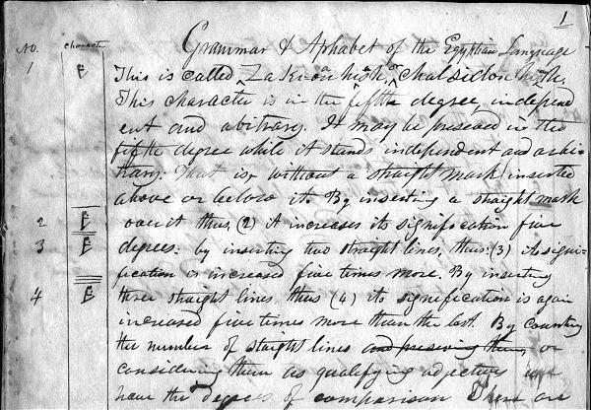
Figure 21: Page from Joseph Smith’s Egyptian Alphabet and Grammar

Equally revealing of something Masonic are pages and pages of what seem to be vital esoteric data for the journey in the next life: names of twelve fixed stars and the fifteen moving planets, for example (p. 24). In the Second part of the 4th Degree, the various titles and words for the celestial hierarchy of angels and planets, of prophets, priests and kings, and intercessors sent on our behalf are listed (pp. 27-28). In the Second parts of the 1st, 2nd and 3rd Degrees a similar accounting appears--names and the celestial abode of God and the Heavenly Hosts (pp. 29 - 34). On page 35 and thereafter (these pages numbered alphabetically A through F) more Masonic and esoteric minutia can be found.
In fact, it was a rudimentary knowledge of Hebrew along with a Masonic agenda of some revisionist sort that gave us the Book of Abraham, but more importantly the scriptural basis for a new understanding of the relationship between race and Priesthood. For Orson Pratt (another pupil of Seixas), Hebrew proved invaluable in the defense of polygamy, for example, and when Dr. John P. Newman, chaplain of the United States Senate, traveled to Utah to defend monogamy, he had his ears boxed. For Smith, reading the Bible in the original Hebrew alerted him to several important “facts” that might very easily change everything vis-à-vis race in particular. That the name of one of the descendants of Ham is Cush, the Hebrew word for “black,” led naturally to speculation that the Canaanites were Africans and vice versa.
The case of Charles B. Thompson is instructive. A Mormon dissident in 1838, he nonetheless authored of an early defense of the Book of Mormon in 1841 and, after Smith’s death, joined forces with James B. Strang. On the eve of the Civil War, Thompson used his knowledge of Hebrew to attack African Americans as the offspring of the Devil in a tract, entitled “The Nachash Origin of the Black and Mixed Races.” He argued that the Hebrew word for snake, “nachash,” had been mistranslated by biblical scholars, related to “cush,” and proof in his opinion that Blacks descended from the serpent. Indeed, Thompson’s notion of Zion was intensely racist and the exclusive preserve of the tribe of “Baneemy-Ephraim” or Sons of Ephraim from which he and his followers claimed to descend.
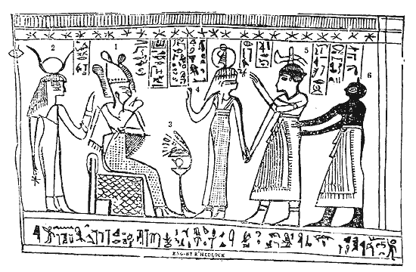
Figure 22: Book of Abraham Facsimile No. 3
Smith’s publication of the Book of Abraham in 1842 coincided with his investiture as a Master Mason; his Egyptian grammar can be seen as a template for something Masonic. E. Cecil McGavin in his Mormonism and Masonry underscores the importance of this, and that “there are so many traces of Masonry.” Smith’s study of Hebrew, as we will see in subsequent chapters, radically redefined the relationship between race and Priesthood, overturning the original Book of Mormon dream of a tri-color kingdom of red, white, and black peoples.
The Book of Abraham Itself: Composition, Rhetorical Style, and Biblical Form
Of the five chapters that make up the Book of Abraham, 4 and 5 parallel Genesis 1:1 - 31 and 2:1 - 20. Polemicists often focus on these chapters and only these to make a case for plagiarism. However, Abraham 4 and 5 can also be seen as a literal translation into English from the Hebrew. Compared to the English of the KJV, Smith’s translation of Genesis 1 and 2 in Abraham is reckless and expansive, much of it simply coming from the ether. However, compared to the Hebrew, the same passages can be seen as translation in the style of Jewish midrash, Smith taking his cue from the Hebrew, and so the original Massoretic text a jumping off point for an interpretative flourish of the antebellum radical variety--playful and creative to be sure, but a translation all the same.
A few examples will suffice. Genesis 1:5a in the KJV reads: “And God called the light Day, and the darkness he called Night.” The parallel text in Abraham reads: “And the Gods called the light Day, and the darkness they called Night.” In this case, Smith merely conjugates the verb to agree in number with its subject, Elohim (the Gods) which is plural not singular. Genesis 1:5b in the KJV reads: “And the evening and the morning were the first day.” In Abraham it is much longer: “And it came to pass, that from the evening until morning they called night; and from the morning until the evening they called day; and this was the first, or the beginning, of that which they called day and night.” Such expansiveness is possible, but only in the original Hebrew, which reads, literally: “and it came to pass [the verb ‘to be’], evening [noun, subject], and it came to pass [the verb ‘to be,’ again], morning [noun-subject], a day [noun-object], one [adjective].” Smith takes some liberties to be sure, but with the Hebrew syntax in this case and not uncommon among Rabbinic translators and commentators.
Multiple English equivalents for individual Hebrew words in question account for much of the rest. In Abraham, the Gods “comprehend the light, for it was bright.” They do not “see” that it was “good” as in the KJV. However, the Hebrew verb “to see” can also mean “to learn” or “to know.” Smith’s preference for “bright” instead of “good,” the translation in the KJV, accords with the Talmudic understanding, moreover. Elsewhere in Abraham, “good” is translated as “obey,” also Talmudic (p. 521). “And God said” is translated “and the Gods ordered,” which then makes more sense given the translation of “good” as “obey.” Throughout, Smith appears to thumbs his Hebrew lexicon rather than consult the Urim and Thummim in search of new definitions and meaning. He translates the Hebrew word for “day” as “time”--one of six possible meanings in Brown, Driver and Briggs’ Hebrew Lexicon of the Old Testament (pp. 398 – 399). In Abraham, the Gods “counsel among themselves” before going down to earth to create the first man and woman. This also accords with the Hebrew in this case and which also means “to contract or bargain.” Adam and Eve, it says in Abraham, “shall be very obedient,” and how Smith translates the Hebrew word for “good,” which in the Talmudic lexicon can also mean “to be obedient.” In Abraham 5, a host of alternative English translations of the Hebrew appear that are there in the lexison: “form” instead of “make,” “counsel” instead of “say,” and “obey” instead of “good.”
Abraham 3 is quite different. Chock full of astronomical data, a litany of Hebrew names for the sun, moon and stars, it appears to take its cue from the Cabala and Zohar. It is also a Neo-Platonic argument that positions Abraham high atop of a great chain of “intelligences” (astrological and human) emanating from the Divine. Smith’s translation of the Hebrew word for “day” as “time” becomes the basis for a commentary or midrash that is cosmological in the main, expounding the hidden meaning of the text and Abraham’s secret identity in the pre-existence and position of preeminence in the grand heavenly court.
Abraham 2 takes liberties, but in this case Smith is only guilty of a creative retelling of the story of Abram’s trek to Egypt with his hauntingly beautiful wife Sarai in Genesis 12 and how claiming to be brother and sister keeps them both safe from harm. In this case, the Mormon Prophet rearranges the order of the chapters in question (Genesis 11: 28 – 29; 2: 2 -13; 15:5 - 7) and verses to suit his purposes. Abraham 2 is essentially a pastiche--Genesis 12:10: 11:28,29; 12:1,4,5,7; 15:5 - 7; 12:2,4,5,6,7,6,7,8,9 – 13—but with a purpose in mind. Here, the “seed of Abraham” as exclusive in nature is elucidated. Importantly, this conforms to the Hebrew understanding of “seed” as “restricted to one line” and “same blood.” In the Rabbinic tradition, Ishmael has no rightful claim to Abraham (the Priesthood) because of his race, a being of “mixed blood.”
Smith merely reorganizes the biblical material, but in order to link the Priesthood to a particular race and divinely-sanctioned genealogy. Genesis 12:2 and 15:5 - 7, from which Abraham 2 is drawn, attempts to establish a biblical basis for the Talmudic understanding of the Priesthood. In the KJV, Genesis 15:5 reads: “And he brought him forth abroad, and said, look now toward heaven, and tell the stars, if thou be able to number them: and he said unto him, So shall thy seed be.” In the following verse, 15:6, it says: “And he believed in the LORD; and he counted it to him for righteousness.” The Hebrew word for “righteousness” here can also be translated as either “priest” or “Priesthood.” Smith’s translation of these biblical verses is an interpretation and reads: “I sought mine appointment unto the Priesthood according to the appointment of God unto the fathers concerning the seed” (Abraham 1:4). Here “Priesthood” and “seed” are synonymous. Moreover, “appointment” and “reckoning” are given a racial and priestly connotation. Abraham’s “appointment” or “reckoning” is given a Talmudic meaning and thus his lineage alone qualifies him “to occupy or to hold a high position.” He is as “a follower of righteousness” and “prince of peace” who desires to become a “rightful heir, a High Priest.”
Indeed, Abraham’s claim to the Melchizedek Priesthood is so dependent upon genealogy that an unbroken line of decent is said to reach back to Adam, “our first father, through the fathers.” Importantly, as Winthrop D. Jordan points out, “there did exist a specific textual basis for utilizing the curse as an explanation for blackness--but it was a specifically Jewish rather than a Christian one.” In the Babylonian Talmud, for example, Ham is said to be “smitten in his skin” and Noah is alleged to have told him: “your seed will be ugly and dark-skinned.” Canaan, Ham’s son, is accused of being “the notorious world-darkener,” too.
That the Book of Abraham is so laden with Hebrew makes a certain sense given its alleged links to Abraham, a Hebrew speaker after all and writing in Hebrew, but using Egyptian script and funeral texts as his medium--perhaps. The name of the wicked priest, Elkenah, is Hebrew. Egypt’s gods are all given Hebrew names as well: Elkenah (again), Libnah, Mahmackrah, Korash and Shagreel. The controlling idea here seems to be one of Hebrew written using Egyptian “hieroglyphics,” which Smith translates as “rahleenos,” from the Hebrew words ra’h and lineys and which in the Rabbinic lexicon refers to “a string of pearls.” Elkenah is one of the sons of Korah (Korash?) and an adversary of Moses and Aaron (Exodus 6:24; 1 Chronicles 6:23)—which is appropriate. Elkenah means “provided by God.” This, too, may be intentional, for Abraham is about to become a sacrificial lamb if his captors get their way.
Other biblical parallels and frames of reference are worth mentioning. Libnah (Libni) one of the sons of Levi mentioned in the same chapter as Elkenah (Exodus 6:17). Mahmackrah, which means “on the morrow,” appears only three times in the Hebrew Bible: Lot’s seduction by his daughters for posterity’s sake (Genesis 19:34), the great mystery that “the LORD is greater than all gods” revealed to Moses on Mount Sinai (Exodus 18:11), and Moses’ lamentation that “this people have sinned a great sin and have made themselves gods of gold” (32:30 - 31). Korash is the Hebrew spelling of Cyrus, the Persian potentate who liberated Babylonian Jewry (see Isaiah 44:28). Shagreel means “offspring of God,” but refers to animals. Since the gods in question are all animals, this makes sense.It soon becomes clear that Hebrew—biblical and Rabbinic—is behind much of Smith’s translating.
The Book of Abraham, Egyptian Priesthood, and Beloved of Masons--the Redoubtable Flavius Josephus
Pharaoh is said to be of “the loins of Ham” and “partaker of the blood of the Canaanites by birth.” The text goes on:
From this descent sprang all the Egyptians, and thus the blood of the Canaanites was preserved in the land. The land of Egypt being first discovered by a woman, who was the daughter of Ham, and the daughter of Egyptus, which in the Chaldean signifies Egypt, which signifies that which is forbidden. When this woman discovered the land it was under water, who afterward settled her sons in it; and thus, from Ham, and it was after the manner of the government of Ham which preserved the curse in the land. . . . Pharaoh, being a righteous man, established his kingdom and judged his people wisely and justly all his days, seeking earnestly to imitate that order established by the fathers in the first generations, in the days of the first patriarchal reign, even in the reign of Adam, and also of Noah, his father, who blessed him with the blessings of the earth, and with the blessings of wisdom, but cursed him as pertaining to Priesthood. Now, Pharaoh being of that lineage by which he could not have the right of Priesthood, notwithstanding the Pharaohs would fain claim it from Noah, through Ham, therefore my father was led away by their idolatry (21 - 27).
The message could not be much clearer. Living in accordance with the patriarchal system of family, church and state government (as the founders of Egypt tried to do) does not overcome the problem of lineage or race vis-à-vis the Priesthood.
Josephus argues along similar lines, and it is important to remember that his Antiquities of the Jews purports to be an abridgement of a pristine draft of the Holy Scriptures not unlike the Book of Abraham. “For the four sons of Ham,” Josephus explains in Chapter VI:
time has not at all hurt the name of Chus; for the Ethiopians, over whom he reigned, are even at this day, by themselves and by all men in Asia, called Chusites. The memory also of the Mesraites is preserved in their name; for all we who inhabit this country [of Judea] call Egypt Mestre, and the Egyptians Mestreans. . . . Now all of the children of Mesraim, being eight in number, possessed the country from Gaza to Egypt (p. 31).
“Chus” is Hebrew for “black.” In Josephus, the story of Noah’s nakedness and Ham’s disrespect is virulently anti-African. “And when Noah was made sensible of what had been done, he prayed for posterity to his other sons; but for Ham, he did not curse him, by reason of his nearness in blood, but cursed his posterity.” Implicit is the notion that Ham’s son, Canaan, was of mixed blood. In Josephus, Abraham is charged “to keep his posterity unmixed with others” and the children of Canaan in particular (p. 34).
William Whiston, the famous translator of Josephus (most of his very considerable scholarly ability and energy expended on reading ancient works in their original tongue in the hopes of unraveling the mystery of the precise date of the Second Coming of Christ) argues along the same lines in a dissertation, entitled “Concerning God’s Command to Abraham to Offer up Isaac, His Son, For a Sacrifice.” In it he quotes the following in John Marsham’s Chronicon:
That long before the days of Abraham, the demons or heathen gods had required and received human sacrifices, and particular that of the offerer’s own children, and this both before and after the Deluge. . . . They relate that of old the [Egyptian] kings sacrificed such men as were of the same color as Typho, at the sepulcher of Osiris. . . . The barbarous nations did a long time admit of the slaughter of children, as of a holy practice, and acceptable to the gods; and this thing, both private persons, and kings, and entire nations, practise at proper seasons. . . . This was, I think, an abomination derived from him who was a murderer from the beginning (pp. 648 - 649).
Whiston took his cue from Josephus whose extra-canonical account of Abraham’s flight from Chaldea is echoed in the Book of Abraham. “He began to have higher notions of virtue than others had,” Josephus writes:
and he determined to renew and to change the opinion all men happened then to have concerning God; for he was the first that ventured to publish this notion, that there was but one God, the Creator of the universe; and that, as to other [gods,] if they contributed anything to the happiness of men, that each of them afforded it according to his appointment [emphasis mine], and not by their own power. . . . For which doctrines, when the Chaldeans and other people of Mesopotamia raised a tumult against him, he thought fit to leave that country; and at the command, and by the assistance of God, he came and lived in the land of Canaan (p. 32).
Abraham’s journey to Egypt, Josephus opines, was primarily intended “to become an auditor of their priests, and to know what they said concerning the gods; designed either to follow them, if they had better notions than he, or to convert them into a better way, if his own notions proved the truest” (p. 33). Accordingly, Abraham “communicated to them [the Egyptians] arithmetic, and delivered to them the science of astronomy” (p. 33).
In the Book of Abraham (chapter 3), Abraham is also an astronomer and expounds on the hierarchy of planets and “the governing ones” with a star nearest to God, Kolob, a divine pairing of considerable importance. Kolob does not appear in the Bible, but it is another Hebrew compound meaning either “the voice of the father,” that is, Qol-ab, or from qul and thus “the light of the father.” Hebrew names for the sun, moon, and stars are listed, Kokaubeam, for example, the Hebrew for stars but a Seixas spelling (Abraham 3:16). Gnolaum is another, the Hebrew word for “eternity” that accords perfectly with what appears in Abraham 3:18. Shinehah, the sun, and Olea are problematic. Shinehah is, no doubt, Shikenah or the divine light, whereas the Hebrew origin of Olea is less certain, either Orah or Oryah, the Hebrew word for “light” which, in the feminine (Oryah/Olea), refers to “moonlight or starlight” and the intended meaning here.
The Book of Abraham and Christian Masonry in Antebellum New York
An intense desire to read the Bible in the original Hebrew transformed the Mormon Prophet into a biblical literalist, but with an esoteric, mystical, and revisionist Christian-Masonic agenda. All of the Hebrew in the Book of Abraham, but more importantly Abraham as the center-piece of a new revelation published the same year Smith became a Master Mason, can be seen as Masonic through and through despite its connection to the Bible. Salem Town’s 1816 work, A System of Speculative Masonry, is a case in point, written for the Grand Chapter of Royal Arch Masons of Albany, New York and a defense of Christian Masonry. For Town, the Old Testament and Masonry had “the same co-eternal and unshaken foundation . . . in substance, the same truths, and purpose,” and thus “the same ultimate end, as the doctrines of Christianity.” Town’s defense of the sanctity of the Bible has an almost Evangelical sense of reverence, “a standard for the correctness and sanctity of our principles” (p. 49). However, it is a means to an end, and Town used holy writ to defend the antiquity of Masonry as “ancient Christianity” in essence (p. 84). Accordingly, “the same truths” are said to “have existed in each antecedent period, since the days of Noah, and might have been discovered and duly improved” (p. 85); moreover, the patriarchs were Christians according to Town, and their belief in Jesus was a corollary of the mysterious Word or Logos--connected to the Divine Name or Tetragrammaton--that had been passed down from father to son starting with Adam. For Christian Masons, Jesus was (the Grand Omnific) Word, or Jehovah.
The Book of Abraham departs from the Bible when it suggests that Abraham was privy to the Divine name. Finding himself under the blade of Elkenah and a potential victim of human sacrifice, Abraham lifts up his voice to heaven and then suddenly, not unlike Moses, is in the presence of the Deity. “And his voice was unto me,” it says in Abraham 1:16, “Abraham, Abraham, behold my name is Jehovah.” The Bible begs to differ: “And I appeared unto Abraham, unto Isaac, and unto Jacob, by the name of God Almighty, but by my name JEHOVAH was I not known to them” (Exodus 6:3), although Abraham refers to the Almighty by name in Genesis 15:7 - 8. In Smith’s Inspired Version of the Bible, it is an interrogative. “Was not my name known unto them?” is not only a very simple solution to the problem of Exodus 6:3 versus Genesis 15:7 - 8, but one that does not go beyond the bounds of Hebrew grammar and syntax--and that is interesting in itself. However, the Book of Abraham reveals exactly how and when this happened--that Abraham was taken into the presence of the Deity as he awaited certain death at the hands of the wicked Egyptian priest, Elkenah. “And his voice was unto me, Abraham, Abraham, behold my name is Jehovah” (1:16).
Abraham plays a central role in Town’s defense of Christian Masonry as well. “Abraham, the father of the faithful,” Town writes,
is claimed as one of the primitive brethren, and an active patron of the ancient principles of our order. This man by nation was an idolatrous Chaldean, yet, being called of God, he became a most eminent christian [sic], and a distinguished instructor in the principles of christianity [sic], and the art of geometry or Masonry.--To him, God made special manifestations of his loving kindness, and established the true church in his family (p. 119
Aaron and Melchizedek are the titular heads of the “Priesthood of the Son of God” (p. 121).Town’s speaks of “the great scheme of Redemption began to be published to our first parents immediately after their apostasy” (p. 171) and that “through his [Abraham’s] lineal descendants, the church was preserved from one generation to another, till the advent of the promised Messias” (pp. 172 - 173), which is the message of the Book of Abraham.
Town’s defense of Christian Masonry had an eschatological component, as well. “A happy Masonic millennium period,” he wrote in 1816, “will soon commence, to the inexpressible joy of all the inhabitants of the earth” (p. 176), but a postmillennial vision for the future as a thousand years of peaceful coexistence along fraternal lines that would “rise in the estimation of mankind, till it shall eventually receive universal approbation from all nations” (p. 179). The hope was that “the whole world might become brethren of one common family” (p. vi, cf. p. 176), and in accordance with the racial vision in the Book of Mormon, where “the rude savage . . . meets the civilized Mason as his brother” and thus “all distinctions of nation, creed and color, are most happily forgotten on Masonic ground” (p. 110). Where and whether such a meeting might take place was the real question. The Book of Mormon had entertained high hopes of just such a Christian-Masonic millennium, but by the 1840s and the relocation to Illinois, the erstwhile Mormon-Masonic millennial dream was fast becoming one of chosen people rather than promised land, a kingdom of blood rather than soil and a transnational, imperial vision for the future.
The Book of Abraham and Magic-Masonic World View
Although the Mormon Prophet eventually became a Mason, he may have preferred to keep his friends close, his enemies closer. His original plan to revitalize Freemasonry in the wake of the Morgan Affair by including women as active and equal participants in what would become a new and clandestine order of Knights Templar located him on the side of Christian Masonry. The Book of Abraham suggests that he did not replace the crude magical beliefs and practices of his money-digging youth with a more mature religious vision, but an esoteric Masonic one synonymous with the Christian Cabala, Transcendental Magic, and Egyptian Rite Masonry. What these have in common with Smith’s more sophisticated thinking of the 1840s is a harder line on the origin, character, and destiny of Africans as the “seed of Cain” and apostate Priesthood.
Francis Barrett’s 1801 work, The Magus, is instructive, in part devoted to the so-called science of “Cabalistic Magic.” It was written with Christian Masons in mind, and begins with an oath of secrecy. In Chapter IV of Book I, the “divine emanations” and “ten sephiroths” are discussed: divine powers that flow from on high. “The Cabalists most learned in divine things,” Barrett explains:
have received the ten principal names of God, as certain divine powers, or, as it were, members of God; which by ten numerations, which we call Sephiroth, as it were vestments, instruments, or exemplars of the Archetype, have an influence upon all created things, from the highest to the lowest; yet by a certain order; for first and immediately they have influence upon the nine orders of angels and quire of blessed souls, and by them into the celestial spheres, planets and men; by the which Sephiroth every thing receiveth power and virtue (p. 36).
What follows are the names of three great ruling planets and their respective divine rulers in order of preeminence--Eleia, Jod, and Tetragrammaton Elohim. The first of these, Eleia, is reminiscent of the name given the moon in the Book of Abraham, that is, Olea. Regarding the seventh designation, Barrett writes: “it hath its influence though the orders of principalities, whom the Hebrews call Elohim, i.e. Gods (p. 37). In Chapter VI, the hierarchy of intelligences and spirits are discussed. “An intelligence,” Barret explains, “is an intelligible substance . . . and the nature of all intelligences, spirits, and angels is the same” (p. 42). Super-celestial angels are said to be “Gods” proper. There are twelve princely angels who are said to rule the twelve signs of the Zodiac; thirty-six rule the decans, and seventy-two rule the elements, whereas seven others govern the seven planets, leaving a host of lesser angels to minister on earth (pp. 42 - 43). These ministering angels, Barrett explains, are as numerous as the stars (p. 45). Finally, underneath them are a class of fallen angels, the devil “being made an apostate, persuaded many of the angels to fall with him” (p. 47).
Abraham 3 contains a lot of information of this transcendental kind: the planets are given names and divine overseers, there is talk of a hierarchy of “intelligences,” and the devil is said to be one such bright light who “was angry, and kept not his first estate, and, at that day, many followed after him” (Abraham 3:28).

The Ordeal of Abraham and the Egyptian Rite(s) of Fortitude
The opening chapter, where Abraham escapes the long knife of a wicked Egyptian priest named Elkenah and the equally perverse institution of human sacrifice said to exist at the time, can be seen as a variation on a Christian-Masonic theme, but Egyptian rather than Templar. Egyptian Rite Masonry descends from Christian Masonry and the Knights Templar. Among the best known Egyptian Masons are the Shriners or “The Ancient Arabic Order Nobles of the Mystic Shrine.” According to Noble William Ross, recorder and historian of the Lu Lu Temple in Philadelphia, the Order of the Mystic Shine was founded in New York in 1872 by William J. Florence, Dr. Walter M. Fleming, and Albert Leighton Rawson. Although the name of the order is taken from the Muslim order founded by Ali in C.E. 644, Shiners do not wish to be seen as Arabian Muslims, but rather a Priesthood line of pureblood Coptic Christians (p. 384). As Ross explains: “That the Order existed hundreds of years prior to the days of Kalif Ali may be accepted as an historical fact. . . . Facts, held up to the public view and upon which the light of heaven shines, never fail to convince. Upon facts we present out case” (pp. 385 - 386). “When we see tablets,” he argues,
upon which are plainly printed the Rules and Regulations which govern the Order of the Mystic Shrine, and which have been easily deciphered by reliable professors who have made a life-study of such matters, and which tablets have lain for ages untouched and unseen until the explorers began their work and opened up priceless treasures, we meet a truthful fact that requires no fiction to polish (p. 387).
Shiners are not unlike Christian Fundamentalists in their reference for the Bible, too, believing strongly in a literal interpretation of the creation story. They are determined to prove the historicity of Adam, for example, “that the world was created in six periods of a thousand years each, ending with the birth of Adam, making the earth six periods of a thousand years each” (p. 392).
Reminiscent of the Book of Mormon, Shriners believe that the Indians were not only Hebrews, but that secret societies of the Coptic or Shriner kind flourished in the new world--in Peru, Chile, and Mexico--long before Columbus (p. 416). The proof of this, ironically, is said to be the existence of “characters on metallic plates . . . the metal of which these sheets composed . . . absolutely invulnerable” as proof of this (p. 491, n. 2). In the same vein as the Book of Abraham, too, Egypt’s priests “invented a system of secret writing called hieroglyphic, on purpose to conceal their knowledge from all but the initiated” (p. 394). Indeed, Ross claims that among the discoveries by scholars of Egyptian antiquity was a parchment concealed in an underground vault and containing the “ritual, the signs, grips and words of the Order” (p. 396). The recovery of metal plates and Egyptian papyri testifying to the Christian origins of Masonry and vice versa is the stock in trade of the Ancient Arabic Order Nobles of the Mystic Shrine.
Shiners also include women. “Egypt, notwithstanding the general rigidity of her institutions,” Ross explains, “provided an open career for talent, both to men and women alike, such as scarcely existed elsewhere in the old world. . . . So women gloried in an equal chance with men, and thereby become comrades with the best element of humanity” (p. 401). That said, the “words, signs or other private essentials [of] the [Noble] Order was made a secret one to men only” (p. 401). Mormonism represents a more equal distribution of the ritual and its mysteries among its men and women. Shriners also reject polygamy because it militates against gender equality in their view (p. 400).
Importantly, Egyptian Masonry has had several incarnations, and two precede the advent of Mormonism in 1830 and the creation of the Endowment or temple ceremony in the 1840s. The first of these, the Rite of Misraim, was in France and the brainchild of three Scottish Rite Masons with strong hermetic leanings, making its way across Europe and America by the early 1820s. The Rite of Memphis, another clandestine lodge of French origin, made its presence known in 1836 shortly after its inventor Jacques Etienne Marconis was expelled from the Paris lodge of Egyptian Masons of Misraim because of his dark complexion. Marconis called his lodge “Le Negre,” and it would come to America in the 1850s. Both can be linked to the eighteenth-century magus, Cagliostro, whose occult beliefs and free-love practices proved so problematic to the Roman Catholic Church in France. Others sympathetic to the cause of Egyptian Rite Masonry include St. Germain and his chief disciple Anton Mesmer.
Manly P. Hall discusses the history of Egyptian Rite Masonry in a curious little book, entitled Freemasonry of the Ancient Egyptians (1937), which includes a transcript of the Crata Repoa or initiation ceremony consisting of seven degrees in all and of eighteenth-century German origin. However, as Madame Blavatsky argues in Isis Unveiled, the Crata Repoa and Egyptian Masonry for that matter trace their origins to the Hebrew Bible and Egyptian Book of the Dead (pp. 78 - 79). “The metaphysical significance of the death and resurrection of the Egyptian demigod,” he enjoins his Masonic readers, “has for the most part been lost to the modern Craft. It is, therefore, most interesting and fitting that the old secrets should be revived and Masonry rededicate itself to the high purpose for which it was originally devised” (p. 80). The important point is not whether the ideas in Smith’s Egyptian Alphabet and Grammar and Book of Abraham are similar to those in the Crata Repoa and Egyptian Rite Masonry, but rather that both operated according to the same esoteric exegetical guiding principle: the Hebrew Bible and Egyptian Book of the Dead as the inspiration and textual basis for a new Christian Masonic ritual and religious/political order.
The Crata Repoa was not translated into English until the late nineteenth century, and so other parallels are homologous at best. That said, the ritual does help to explain the content in the first chapter of the Book of Abraham and the attempt on his life by the wicked Elkenah. In the third degree or “Gate of Death,” the Neophyte is taken by two persons who inter the dead, gently struck upon the head by a sharp instrument, and then mummified. The degree is a death and resurrection ritual based on exactly the same funeral scene from the Book of the Dead that appears in the Book of Abraham as Facsimile No. 1 (pp. 88 - 90). Moreover, in the fourth degree or “Battle of the Shades” a judgment scene is reenacted that is patterned after another funeral scene from the Book of the Dead that appears in the Book of Abraham as Facsimile No. 3 (pp. 91). In the sixth degree or “Astronomer Before the Gate of the Gods” the aspirant, not unlike Abraham, is schooled in the “history of the origin of the Gods,” on the mystery of polytheism and the science of astronomy (p. 96). Finally, in the seventh degree or “Prophet or Saphenath Pancah” the Neophyte is raised to the station of a prophet and able to read “all the mysterious books . . . in the Ammonique language.
However, “the greatest blessing of the grade,” it says, is the right to “vote in the election of a King” (p. 99). In this case, the medium may not be the only thing that the Book of Abraham and the Crata Repoa have in common, for the two have a similar message as well. The Egyptian Rite of Memphis (with over ninety degrees) also takes its cue from the Egyptian Book of the Dead. In a Canadian edition of the ritual, Constitution, and By-Laws, the parallels to the Book of Abraham are also striking. In the initiation ritual of the Rite of Memphis, “three men armed with swords, and disguised in masks resembling the heads of jackals” greet the aspirant (p. vi). In Facsimile No. 1, the figure identified as Elkenah is erroneous. It is Anubis, the Egyptian god of mummification and a jackal from the neck up. Importantly, Facsimile No. 1 is a reconstruction. In the original, the head is missing, and Smith assumed it was human rather than animal, going on from there to write his midrash. Abraham’s ordeal, and his fear of becoming the victim of someone wielding a knife, is the important point.
The fourth degree or “Discreet Master” makes the point. It is similar to the third degree or “Gate of Death” in the Crata Repoa, but instead of the initiate being knocked on the head, a mock bleeding known as the Trial of Fortitude is performed:
M.W.-Conduct the Neophyte to the ancient and innermost Chamber of the Pyramid, there to undergo the trial of Fortitude, and should he prove himself worthy and satisfy the officers of his courage, devotion and valor, you will re-conduct him to the Sacred Altar to take the vow of a Discreet Master (p. 22).
The Surgeon-General of the Chapter, “Esculapius,” describes in detail what happens next:
That we may now, however, be assured of the steadfastness of your mind; of the depth and sincerity of your devotion, I propose here, in the presence of these brethren, to take from you the amount of blood that you may voluntarily offer to sacrifice. The whole amount of blood in the human body is about 1-13 of the body’s weight. In the bountiful provision of nature’s several pounds of this vital fluid may be lost and against restored; but should the limit of safety be passed and your physical life be lost, your name will be enrolled among the gods, and you will be immortal. . . . Sir Knight Conductor and Captain of the Guard prepare the candidate for the blood-letting ordeal; divest him of his outer garments, make bare his right arm and bandage it, place this staff in his right hand; hoodwink him, and when thus prepared notify me and I will be in readiness to take that amount of blood which he proposes to offer up at the shrine of his fortitude (pp. 24 - 25).
A fountain syringe filled with warm water is prepared without the aspirant’s knowledge, and the surgeon only pretends to break the skin; warm water is then poured over the arm and allowed to trickle into a bowl until the candidate faints. Fainting, ironically, proves one’s manhood. “My brother, you see that you have been mock bled; this was not done to trifle with your feelings, but to test your courage” (p. 26).
In the sixth degree or “Sublime Master,” references to the Egyptian Book of the Dead abound. Now the aspirant is Anubis and, as such, “A Child of God” (p. 42). However, the idea or lesson here is one of “the intimacy between Divine and human nature, between God and man; and man being allied with his Almighty Father.” It goes on to explain:
his celestial origin is an undoubted fact. . . . God is his soul, his light, his companion. They both unite through a mutual force of attraction, whence are derived the perfection of man. . . . Therefore, my brother, the Sixth Degree is a solemn initiation into the relations of God with Himself, as necessary and immediate consequences of His existence. His infinite power and unavoidable tendency to produce himself more and more, and manifest His eternal resources, and impress all over the Universe with His Divine image and attributes, become the favorite study of the Candidate. There he is with Jehovah, and he beholds how the Father of man delights in contemplating His work and enjoying the prodigious perfections of the Almighty” (pp. 49 - 50).
Similar ideas appear in the Book of Abraham: Abraham as a noble spirit in the preexistence and of royal blood.
Related to this is the idea of some being unworthy of the Priesthood by virtue of their bloodline. In the Thirteenth Degree of “Royal Arch of Enoch” the story of Enoch, Noah and Ham is recounted. “About the year 2188, before Christ,” it says, “Mizraim, the grandson of Ham, led Colonies into Egypt, and laid the foundation of the Kingdom of Egypt, which lasted 1,663 years. Mizraim carried with him the sacred Delta of the Patriarch Enoch, which he confided to the care of the Hierophants, who deposited it in the Holy Chamber of one of their Temples.” (p. 72). Here, the discussion in the Book of Abraham of the Pharaoh’s claim to the Priesthood through Ham can be seen as a variation on the story of Enoch.
In the Book of Mormon, Smith is the seed of Joseph (2 Nephi 3:7). However, this changed with the publication of the Book of Abraham. “Abraham received promises concerning his seed, and of the fruit of his loins--from those loins ye are, namely, my servant Joseph. . . . This promise is yours, also, because ye are of Abraham. . . . Go ye, therefore, and do the works of Abraham; enter ye into my law and ye shall be saved” (D&C 132:30 - 32). As a descendant of Abraham and of royal blood, Smith’s self-understanding and mission changed rather dramatically. For Smith, the measure of Abraham’s manhood was not a matter of fainting at the thought of too much blood spilling into a bowl, but of failing to practice polygamy as a sure way to avoid spilling royal seed on the ground in the re-creation of the royal Priesthood lineage. Important, the failure to realize the Book of Mormon’s dream of a promised land of red, white, and black on the edge of the Western frontier (Jackson County, Missouri), the early Mormon metamorphosis from Templar to Shiner proved to be an excellent exit strategy and new ritual basis for the religion’s evolving national self-understanding.
Indeed, the coded word in early Mormonism acted very much as a tabula rasa for a variety of political and social strategies, evolutions or devolutions depending on one’s point of view in the Mormon-Masonic-Templar dream of empire.

Antoine Faivre, Access to Western Esotericism (Albany, New York: State University of New York Press, 1994).
. Wouter J. Hanegraaff, New Age Religion and Western Culture: Esotericism in the Mirror of Secular Thought (New York: State University Press of New York, 1998), p. 398. The second, “living nature,” refer to “the vision of a complex, plural, hierarchical cosmos permeated by spiritual forces” (p. 398). Third, “imagination and mediations,” what Hanegraaff calls “correspondences . . . between higher and lower world(s), by way of rituals, symbols, angels, intermediary spirits” (p. 398) and which distinguishes esotericism from mysticism--the latter dissolving away all such intermediaries, absorbed completely by the ultimate reality. Fourth, “experience and transmutation,” or the quest for knowledge refers to the access to the intermediate realms so important to new religions. Fifth, “the praxis of concordance” is the search for the primordial secret doctrine and key to the mysterious unity behind all religious experience. And sixth, “transmission,” refers to the passing of the esoteric teaching via ritual from master to student and as part of an authentic line of authority and historical genealogy.
Jan Shipps, Mormonism: The Story of a New Religious Tradition (Urbana: University of Illinois Press, 1987).
Jan Shipps, Sojourner in a Promised Land: Forty Years Among the Mormons (Urbana: University of Illinois Press, 2002), in addition to recounting the very interesting story of her introduction to Mormonism and Mormon history, living and teaching school in Utah and taking it to the highest level, contains a comprehensive discussion of her scholarly contributions over the years in the Church-Sect paradigm figures prominently. For the purposes of this discussion, the other important point is her criticism of John L. Brooke’s Masonic interpretation of Mormonism. See Brooke, The Refiner’s Fire: The Making of Mormon Cosmology, 1644-1844 (Cambridge: Cambridge University Press, New Edition 2006).
. Hanegraaff, New Age Religion and Western Culture, p. 407.
The source for this is the Book of Mormon (Mormon 9:32): "the characters which are called among us the reformed Egyptian, [were] handed down and altered by us, according to our manner of speech…."
7. Harris and Anthon offered very different accounts of their meeting, Harris’s very positive, Anthon’s extremely negative. "I went to the city of New York and presented the characters which had been translated, with the translation thereof to Professor Anthony (sic), a gentleman celebrated for his literary attainments;-Professor Anthony (sic) stated that the translation was correct, more so than any he had before seen translated from the Egyptian. I then showed him those which were not yet translated, and he said that they were Egyptian, Chaldeac, Assyriac, and Arabac [Arabic], and he said that they were true characters. He gave me a certificate certifying to the people of Palmyra that they were true characters, and that the translation of such of them as had been translated was also correct." Martin Harris, Times and Seasons, III, 773. Cf. Charles Anthon to E. D. Howe, February 17, 1834, in EMD, 4: 380.
See the L.D.S. Church periodical, the Improvement Era (February 1942) where Ariel L. Crowley identifies Egyptian parallels from the Egyptian Book of the Dead and Rosetta Stone. Hugh Nibley, Since Cumorah, 2nd ed. (Salt Lake City: Deseret Book and FARMS, 1988), 149-50. David H. Kelley, "Cylinder Seal from Tlatilco," American Antiquity 31 (July 1966): 744–46. For comparisons to shorthand grammars of the day, see http://latayne.tripod.com/Chapter4.htm. R.L.D.S. (Community of Christ) historian Blair Bryant claims that the hieroglyphs on the Anthon Transcript correspond to the title page of the Book of Mormon, whereas Stan and Polly Johnson argue in Translating the Anthon Transcript (Parowan, Utah: Ivory Books, 1999) that they are from Ether 6:3–13, one of the fifteen books that comprise the Book of Mormon.
See Arturo de Hoyos, "The Mistery of the Royal Arch Word," Heredom, Vol. 2 (1993), 11, n 24.
See in this connection, David E. Newton, "Freemason's Cipher" in Encyclopedia of Cryptology (1998).
The New York Herald, Wednesday, April 6, 1859 edition, "One prominent and striking feature connected with the News just received is the introduction into its columns of the new Mormon alphabet. It is clearly the intention of brother Brigham to have his people go to school again. Every number of the paper is to contain familiar portions of the Bible, so that the people may the more easily acquire a knowledge of the new language. As the apostle Hyde says in his epistle, that the Mormons are 'a very peculiar people,' with many peculiarities--and none doubt him--the language now introduced is calculated to make the faithful still more peculiar than anything that distinguishes them from other mortals. Gentiles are not likely to take much trouble to acquire a knowledge of the new characters, so that in course of time we may expect to be cut off from much that we have been accustomed to receive from the Rocky Mountains. The characters seem a conglomeration of the Celtic and the phonotypic, and are intended, like the latter, to represent distinct sounds. No classification is made into vowels and consonants, as that is by them considered of little consequence. 'The student is, therefore at liberty to deem all the characters vowels, or consonants, or starters, or stoppers, or whatever else he pleases.' There is no perfection claimed for the system, but the projectors 'are sanguine that the more it is practiced and the more intimately the people become acquainted with it, the more useful and beneficial it will appear.'" Also see Glenn N. Rowe, "Can You Read Deseret?," Ensign, Mar. 1978, 60-61. Frederick M. Huchel, “The Deseret Alphabet as an Aid in Pronouncing Book of Mormon Names” Journal of Book of Mormon Studies, Vol. 9 (2000), 1, 58-59.
See Henrich Cornelius Agrippa von Nettesheim,, Three books of occult philosophy, trans. J.French (London : Printed by R.W. for Gregory Moule, 1651) and Johannes Trithemius, Polygraphia (1518).
John Dee (1527-1608), Mysteriorum Libri Quinque (The Five Books of the Mysteries), edited & translated by Joseph H. Peterson (Wales: Magnum Opus Hermetic Sourceworks, 1985.)
What follows is a breakdown of new characters and their Hebrew equivalents in the order they appear. The fact that a near-comprehensive list like this is possible is merely intended to illustrate the problem. Block Hebrew - Ayin: line 1 - Daleth: 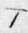 line 3 - Beth: line 3 - Zayin: line 4 - Tzade (final form): line 3 - Lamed: 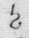 line 4/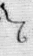 line 4 Cursive/Rabbinic - Daleth: line 1/ line 2/ line 2/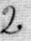 line 4/ line 5/ line 5 - Beth/Tzade: line 1/ line 2/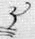 line 3/ line 6/ line 7 - Mem/Nun (Ivri): line 1/ line 2/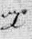 line 2/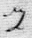 line 4/ line 6/ line 7 - Vav/Nun: line 3/ line 4/ line 4/ line 6 - Aleph: line1 - Sin/Shin: line 1/ line 1/ line 5/ line 7 - He: line 1/ line 2/ line 3/ line 4 - Tav (Ivri): line 1/ line 2/ line 2/ line 5/ line 6/ line 6/ line 7 - Tav: line 1/ line 2/ line 3/ line 4/ line 5/ line 5/ line 5/ line 6/ line 6/ line 7 - Zayin: line 1 - Pe (final form): line 1/ line 3/ line 5/ line 6 - Daleth/Samekh (archaic): line 1/ line 5/ line 5/ line 6 - Tav: line 1/ line 7 - Lamed/Teth: line 1 - Kof (archaic): 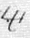 line 1 - He/Het: 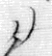 line 1/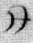 line 2/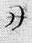 line 2/ line 4/ line 6/ line 7/ line 7 - Tzade (final form): line 2 - Gimel: line 2/ line 5/ line 6/ line 6/ line 7 - Lamed: line 2/ line 3 - Samekh: line 3/ line 3/ line 4/ line 5 - Beth/Kof: line 3/ line 7/ line 7 - Teth: line 3 - Pe: line 3/ line 4 - Lamed: 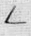 line 3/ line 5 - Resh (Ivri): 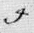 line 3/ line 6/ line 7 - Sin/Shin (Ivri): 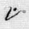 line 3/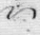 line 4 - Resh: line 4/ / line 7 - Kof: line 6 - Zayin: line 4 - Lamed/Tzade: line 5 - Tzade: line 6. - Beth (Rashi): line 5/ line 7 Arabic: 1. Kaf + Waw: line 5 2. Sin + Mem: line 5 3. Kaf: line 6 4. Ayin: line 6/ line 7/ 5. Mem + Mem: line 7
See “ALPHABET, SAMARITAN” in Mackey’s Online Masonic Encyclopedia. Importantly, this is a facet of the Scottish or Pike Ritual. http://books.google.com/books?id=lU5e-E6wBeEC&pg=PA146&lpg=PA146&dq=Mackey's+online+Encyclopedia+of+Mormonism&source=bl&ots=v1fvskKAzd&sig=D2urRhKENqRlTdqzYe-BCm9GPko&hl=en&ei=kcKVTP3uB5LovQP7kfSZDQ&sa=X&oi=book_result&ct=result&resnum=2&ved=0CBYQ6AEwAQ#v=onepage&q&f=false
E. Smith, A Vocabulary: Hebrew, Arabic, and Persian (London: A.J. Valpy, 1814).
See in this connection, Memoir of the Life of Thomas Young, M.D. F.R.S, with a Catalogue of his Works and Essays (London: John and Arthur Arch Cornhill, 1831). Some of the characters in the Anthon Transcript that seem undeniably hieroglyphic, Egyptian, and Demotic, at least in form, include the following: 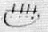 line 1/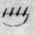 line 2/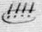 line 4/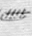 line 5/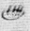 line 6/ line 7 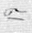 line 1 line 2/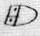 line 3/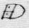 line 4  line 2—Hieroglyphic/ line 6/ line 7 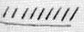 line 2/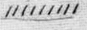 line 3 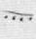 line 4 line 5/ line 6 line 6
(London: A. Lewis, 2007).
See the complete translation of the page in question by S. Brent Morris: ADDRESS ON THE BIBLE “W.M. This great light of Masonry is ever open in a proper Lodge, to that end that we should be reminded of the duty, that of learning and practicing the excellent precepts it contains. And if we, as far as we can, scrupulously examine both the character of those who gave the precepts and the influences they have had upon society and still have upon it, if we examine the great ends and views of the doctrines here written, and thus become acquainted with this volume, we shall experience that this volume is an inestimable treasure and should be viewed as such by all good men. It is in fact the book that contains the rules of life pointing out to man his whole duty. This volume is of great antiquity, and splendid monuments of the ancients have decayed and nations who peopled the countries where these things were written have vanished or are scattered over the face of the earth, their former places of abode are desolate, the languages the book was written in are dead, yet the book survives. And the enemies of order and opposers of the good precepts this volume contains have sought with astonishing obduracy and unwearied pains, with jests, with philosophy falsely so-called, with misapplied learning, with every effort of their genius to bring this volume into contempt. But they have been engaged in a foolish work. All their pains have been taken in vain. It stands deservedly now in higher estimation than ever. Considering the character of the writers for this volume and finding them to be good, even inimitably so, examining the doctrines contained in this volume, and observing their unison with truth and their beneficent influence upon society and upon individuals, thinking upon the great antiquity of these writings and the many revolutions which they have survived and their complete victory over the efforts of enemies, therewith continually increasing in the estimation of the world at large of the friends of good order and of truth, then it can be said, even if there were no other reasons for so saying, that this volume is not to be neglected, but, on the contrary, that it ought to be examined and should be made the subject of our attention and study. And see how correct is its philosophy, how interesting the history, how sublime and beautiful the poetry, how acceptable the doctrines of religion and morality contained in this volume. It is calculated in every point of view to engage our attention, and, if attended to, the truths it contains make men better, wiser, and happier, and the benefits arising from these sacred truths are not limited to the period of human life. They point not forward to the grave as the boundary of our existence, as the place where men shall cease to be. No, the thick gloom of death is dissipated by divine truth. A ray of sacred light makes visible to the eye of faith a state of existence beyond the grave, a state of existence, at the approach of which all must fear. For it lasts to all eternity, for it is a state of rewards and punishments, for it is dependent upon Divine mercy, for no man can claim a place there. Happy indeed is the man who has strove to subdue his passions and to lay aside his prejudices, and thus is fitted for the task of the Fellow. And studying and executing the designs and rules of the Master, by contemplating upon the image of the pillar of beauty, he may have observed his own weakness and his own inability to make his work according to the pattern given him by the Master. If he is sensible of his own incapacity and imperfections, he has in truth made the first step toward the light and has thus become more susceptible of the truth than he was. Then he will have the trestleboard in his hands and use all proper means for becoming acquainted with the designs which are drawn, and no doubt he will not only direct others how to exert them, but he will participate in the labour in the erection of the truly noble edifice--a Temple sacred to the name of God. And in this work he will use the implements of the Master. The compasses will remind him to set proper limits to his duties, desires, and actions, not to be eccentric in behaviour, but to preserve any even line of conduct without irregularities. We should, by example and persuasion, try to exact and encourage fraternal love. This is the very cement of the Temple. If it is wanting the whole becomes a heap of rubbish and is of no worth, but on the contrary is an obstacle to those who pass where it lies and nuisance to those who may have a habitation near it. Where fraternal love is not, there must be many evils. There the ruffian passions are enthroned and virtue is driven out or spurned with contempt or bound with thorns. There folly derides wisdom, and truth is obliged to hide her fair face. There religion or morality cannot be found. There all is but mockery. Time we cannot recall, but we can and we ought to use that anght which is to come. [Exhibits hourglass] See the sand. The particles run rapidly, and, for aught we know, with the passing of one of them you or I shall die. It is uncertain. We should not then neglect a moment, but from henceforth do all we can do to the great end of being really happy. For we shall die, and in the grave there is no working. There is no device, no knowledge, no pardon there. [Exhibits skull] See this emblem, this monitor. It is silent vacant dead yet it speaks to our minds. The good hear a sound that even make them tremble. To some it can be a great cause of terror. It reminds all to remember death. We have crowned it with a green sprig, for we hope, in partaking of immortality, immortality and happiness through faith in the giver of every good and perfect gift, and by an earnest striving to do His will. Remembering that man was created in His image and, although, much deformed, can be again restored to his pristine state, be made fit for blissful enjoyments. Remembering that we should not be ashamed of truth and religion, for that would make us unfit for fraternity on earth and disqualify us utterly for the enjoyments of a future state, where love is the most essential requisite. Remembering that we should be charitable and sensible of the wants of our fellow men, for else we are monsters even here, as although associated as Brethren, and therefore would be hereafter unfit for lasting joys. We must have hope to be restored to pristine purity. We must have faith. We must confess the truth. We must exercise love and charity with all our might. These are the rounds of the mysterious ladder that reaches from earth to heaven, and charity is the upper round.” © 1999 S. Brent Morris
. Cited in William Mulder and A. Russell Mortensen (eds.), “Two Boston Brahmins Call on the Prophet,” in Among the Mormons: Historical Accounts by Contemporary Observers (Lincoln: University of Nebraska, 1973), pp. 131-132.
. The Pearl of Great Price (Salt Lake City: The Church of Jesus Christ of Latter-day Saints, 1977 edition).
. Northrop Frye, The Great Code: The Bible & Literature (Toronto: Penguin Books Canada, 1990), pp. 202-203.
. Terryl L. Givens, By the Hand of Mormon: The American Scripture that Launched a New World Religion (New York: Oxford, 2002), p. 178.
. See Mark Thomas, Digging in Cumorah: Reclaiming Book of Mormon Narratives (Salt Lake City: Signature, 1999).
. Givens, By the Hand of Mormon, p. 214.
. Frye, The Great Code, p. 213.
. Hugh Nibley, The Message of the Joseph Smith Papyri: an Egyptian Endowment (Salt Lake City: Deseret, 1976), pp. 47 - 55.
. In this connection, see Hugh Nibley, “Genesis of the Written Word,” in Temple and Cosmos (Salt Lake City: Deseret, 1992), pp. 450 - 490.
. Erik Iversen, The Myth of Egypt and its Hieroglyphs in European Tradition (Princeton: Princeton University Press, 1993), pp. 57 - 123.
. Alexander Turner Cory (trans.), The Hieroglypics of Horapollo Nilos (London: William Pickering, 1840), pp. vii - xii.
. Erik Hornung, The Secret Lore of Egypt: Its Impact on the West, trans. David Lorton (Ithaca: Cornell University Press, 1999), p. 1.
.Originally published in The Utah Survey, 1 (September 1913): 4 - 36.
. Louis C. Zucker, “Joseph Smith As A Student of Hebrew,” in Dialogue: A Journal of Mormon Thought, 3 (Summer 1968), 51. [41 - 55] Also see Joshua Seixas, Manual Hebrew Grammar: for the use of the beginner (Andover: Gould and Newman, 1834).
. Martin A. Cohen, “The Sephardic Phenomenon: A Reappraisal,” in Sephardim in the Americas: Studies in Culture and History, Eds. Martin A. Cohen and Abraham J. Peck (Tuscaloosa: The University of Alabama Press, 1993), pp. 1 - 79.
. Klaus Baer, “The Breathing Permit of Hor: A Translation of the Apparent Source of the Book of Abraham,” Dialogue: A Journal of Mormon Thought, 3 (Autumn 1968): 109 - 134.
. In this connection, see, Hugh Nibley, “A New Look at the Pearl of Great Price,” The Improvement Era, 71 - 73 (January 1968 - May 1970); cf. “The Meaning of the Kirtland Egyptian Papers,” Brigham Young University Studies, 11 (Summer 1971): 350 - 399.
. Nibley, The Message of the Joseph Smith Papyri, p. 1.
. In this connection, see Joseph Smith Jr., Doctrinal History of the Church (Salt Lake City: Church of Jesus Christ of Latter-day Saints), 2: 348.
. Joseph Smith, Grammar & Alphabet of the Egyptian Language (Salt Lake City: LDS Church Archives).
. In this connection, see, James R. Clark, The Story of the Pearl of Great Price (Salt Lake City: Bookcraft, 1955), p. 156.
See Michael De Groote, “FAIR conference: Secret Mormon codes and Egyptian papers,” Mormon Times (Deseret News). http://www.mormontimes.com/article/16366/FAIR-conference-Secret-Mormon-codes-and-Egyptian-papers For online version of Schryver's presentation: www.fairlds.org/fair_conferences
. In this connection, see, Roger Van Hoord, King of Beaver Island: The Life and Assassination of James Jesse Strang (Urbana: University of Illinois Press, 1988), Strang’s copper plates the handiwork of one “Rajah Manchou” (pp. 33 - 47 and illustrations).
. Cited in Louis Zucker, “Joseph Smith As A Student of Hebrew,” Dialogue: A Journal of Mormon Thought 3 (Summer 1968): 53.
. E. Cecil McGavin, Mormonism and Masonry (Salt Lake City: Stevens & Wallis, Inc., 1947), p. 83.
. In this connection, see, H. Michael Marquardt, “The Book of Abraham Papyrus Found: An Answer to Dr. Hugh Nibley’s Book” (Salt Lake City: Utah Lighthouse Ministry, 1981), pp. 25 - 35.
He begins with the verb “to be” and the subject, skipping the second verb “to be” and going directly to the object, reading this forward and then backwards (literally) before leapfrogging to the second verb “to be” which is put to good use, then the adjective, before going back to the object. All can be seen as faithful to the original Hebrew but a playful departure from the original syntax.
. Francis Brown, S. R. Driver, and Charles A. Briggs, A Hebrew and English Lexicon of the Old Testament (Oxford: Clarendon Press, 1978), p. 907. Hereafter simply BDB.
. Marcus Jastrow, Dictionary of the Targumim, Talmud Babli, Yerushalmi and Midrashic Literature (New York: The Judaica Press, Inc., 1982), p. 521. Hereafter simply Jastrow.
. BDB, p. 56.
.Jastrow, Dictionary of the Targumim, p. 78.
. The Hebrew is hakam. See BDB, pp. 314 - 315. The Rabbinic understanding seems most in line with that in Abraham: a council of ingenious minds. In this connection, see, Jastrow, Dictionary of the Targumim, pp. 462 - 463.
. BDB, p. 282.
. The Hebrew is tsdakah. In this connection, see, BDB, p. 843.
. Jastrow, Dictionary of the Targumim, p. 508.
.Winthrop D. Jordan, White Over Black: American Attitudes Toward the Negro, 1550-1812 (Baltimore, Maryland: Penguin Books, 1971), p. 18.
. See The Babylonian Talmud, Sanhedrin, II, p. 745; Midrash Rabbah, I, p. 293; The Zohar, I, pp. 246,247. Cited in White Over Black, p. 18, n. 44.
. Jastrow, Dictionary of the Targumim, p. 708.
. BDB, p. 993.
. In this connection, see, William Whiston, “Dissertation IV: Proving that the copy of the Old Testament laid up in Herod’s Temple and thence used by Josephus, the Jewish historian, in his Antiquities, was no other than that most ancient collection . . . and was free from the several additions and alterations made afterwards in the other copies which are now extant,” in William Whiston (trans.), Josephus Complete Works (Grand Rapids: Kregel Publications, 1983 edition), pp. 662 - 677.
. Jastow, Dictionary of the Targumim, p. 1327.
. BDB, p. 21.
. Salem Town, A System of Speculative Masonry (New York, 1816), p. 2.
. The interrogative in Hebrew is sometimes expressed without the negative as in 1 Samuel 16:5 and 2 Kings 5:25. In this connection, see, R. J. Williams, Hebrew Syntax ( Toronto: University of Toronto Press, 1992), p. 10.
. Francis Barrett, The Magus: Containing Magnetism and Cabalistic Magic (London: Temple of the Muses, 1801), Book 2, p. 35.
. In this connection, see, Robert Freke Gould, A Library of Freemasonry (London : The John C. Yorston Publishing Company, 1911), 5: 383 – 428.
?. Manly H. Hall, Freemasonry of the Ancient Egyptians (Los Angeles: Philosophical Research Society, 1971), pp. 19, 73, 80..
. Ritual of the A. & A. Egyptian Rite of Memphis 96o: Also Constitution and By-Laws of the Sovereign Sanctuary, Valley of Canada (npl: npu, nd).

