“‘Times they are a-Changing’

– Faith Conversations in 2013”

The Rev. Göran Appelgren

The New Church Society in Stockholm, Sweden

A paper presented at the 2013 CESNUR conference in Falun, Sweden

Preliminary version. Please do not copy and reproduce without the consent of the author

“‘Times they are a-Changing’ 0
– Faith Conversations in 2013” 0
“‘Times they are a-Changing’ – Faith Conversations in 2013” 4
Introduction 5
Philosophizing 6
Household Catechism Exams 6
Religion and Freedom of Thought 8
Your Love is Your Life – Your Life is Your Love 8
Good People Revolt Against Oppression and Injustices 9
Taking Responsibility for One’s Own Life 9
The Relevance of Churches 10
Attack on The Faith of Our Youth 11
Main Beliefs in the Swedenborgian Faith 11
Background for These Faith Conversations 12
Christianity 12
‘Pagan’, ‘Atheist’, ‘New Age’ 13
Faith Conversations in 2013 13
Christianity Around the World 14
Scandinavia 14
Groups visiting the church 15
Internet, Scandinavia 18
Students, grade 8-12, age 15-19 20
Church coffee 21
Alcoholics Anonymous 21
Countries Outside Scandinavia 22
Czech Republic 22
Ukraine 23
India, Kerala 23
Cuba 25
Challenging Questions 27
Any Patterns? 27
Analysis 28
Conclusion 30
Bibliography 34

“‘Times they are a-Changing’ – Faith Conversations in 2013”

A paper and presentation by
The Rev. Göran Appelgren
Pastor of The New Church Society in Stockholm
Regional Pastor for Europe and India for the General Church of the New Jerusalem

The CENSOR Conference
CHANGING RELIGIOUS MOVEMENTS IN A CHANGING WORLD
Falun 21-24 June 2013

The proposal
“‘Times they are a-Changin’--Faith Conversations in 2013”
In Western culture, church discipline began losing its power in the 19th century and definitely lost it in the 20th century. There are still pockets of it left in the 21st century, some pretty big--Say Southern Baptists; Say Pentecostals in Kerala, India. But the world is rapidly changing and the individual is given - or demands - more and more freedom to decide how to live his or her life. 1968, the year the world-turned-upside down for older generations is seen by many as a watershed between an “ancien régime” – to allude to another time of big changes – and a new era of personal freedom and an incipient feeling of being one’s own master. As Bob Dylan sang: “Come mothers and fathers throughout the land … your sons and your daughters are beyond your command …”
A modern person who is not tied to a strict religious community is not likely to react positively to an authoritarian approach, where sin and guilt are used to persuade the person to take on the worldview of the “missionary”. Instead, in faith conversations today a person’s freedom has to be given complete respect.
This paper will explore the structure and context of faith conversations in the increasingly broad outreach efforts of the Swedenborgian church.

  

Introduction
I am the Rev. Göran Appelgren, pastor of The New Church Society in Stockholm as well as Regional Pastor for Europe and India within the church organization the General Church of the New Jerusalem. I have been a minister for over twenty years and have worked mostly in Scandinavia but travelled extensively to other countries. The purpose of that travel has been to evangelize in the name of the New Church.
Our denomination has two different names, the Swedenborgian Church and the New Church, Swedenborgian because of Emanuel Swedenborg who claimed to have received revelations from the God Himself, and New Church because Swedenborg uses that term a lot, and the meaning he puts into it is a renewal of the Christian faith.
The different church organizations have different names in which they use some of that terminology. The “New Jerusalem” in our name goes back to Rev 21:2.
Further down I will give a short presentation of the main beliefs in the New Church.
My subject is Faith Conversations in 2013. Those conversations have taken place in the light of and with the inspiration of Swedenborgian thoughts. Most of the conversations I have in mind are with people new to our belief system and our community, but also with the younger generation already connected with us. Our own children are also on a path of soul-searching and inquiry.
Countries I have worked in are these ones:
Scandinavia:
- Sweden
- Norway
- Denmark
Countries outside of Scandinavia:
- England
- America
- Russia
- The Czech Republic
- Ukraine
- Georgia
- India
- Cuba
And lastly the rationale for spending time and energy on trying to understand how we can become more effective in our efforts to reach out and thereby serve our God is that we live in a world that is rapidly changing. We have to adapt to new times. How do we do that? What do we see happening? And how do we respond?

Philosophizing

Household Catechism Exams
Since this conference is held in Sweden and in an area that has become a symbol of Sweden and typical Swedish historic, cultural and maybe spiritual values, it will be very fitting to mention a unique system of making sure the population was steeped in the correct Christian faith, den “rena evangeliska läran”, the pure evangelical faith.
For 300 years, 1596 – 1888, every individual in Sweden had to undergo an examination or inspection by the priest to see if the person in question had the necessary knowledge of the Christian faith. The priest even gave grades.
These exams or inspections were also used to keep a record of the population in the local parish, including births, baptisms, weddings, people moving to another parish, funerals etc.
Sweden was probably the most homogenous country when it comes to Protestantism. The official creed was the Lutheran faith based on the Augsburg Confession (1530) and The Formula of Concord (1576). The king was the defender of faith and all subjects simply had to follow along. Dissent was punished with expulsion from the country. No literature was allowed that was not in accord with pure evangelical faith.
It was as late as 1873 that it was possible for other denominations or church groups to give public worship. The Dissenter Act changed a previous ban on such meetings.
Today Sweden is considered one of the most secular and non-religious peoples in the world. The following is an entry from Wikipedia, and I can assure you that other data I have looked over the years support these numbers:
Despite that, religiosity in Sweden plays a limited role compared to the European average.
- In a Eurobarometer Poll in 2010, just 18% of Swedish citizens responded that "they believe there is a god".
- In a 2009 Gallup poll, 17% answered yes to the question "Is religion an important part of your daily life?".
- Less than 4% of the Church of Sweden membership attends public worship during an average week;
- about 2% are regular attendees. Some scholars consider the nation to be a place where religion is regarded with “benign indifference”.
If we put these two things together, the stern, authoritarian ruling of the people by the priesthood for more than 300 years, and today’s low of being actively involved in religion, we must ask ourselves if there isn’t a connection.
However, I don’t for a moment believe that these low figures reflect what goes on in people’s minds, but what goes on is not church the way we hope or have so far expected. The rest of my talk will hopefully show that such is the case.
A way to analyse these facts is the following symbolic pattern. We compare the Swedish population to a human being that grows up and gets older, and the different age categories define the relationship towards religion.
And the parallel image is a child and its parents. The child follows the directions of its parents without much opposition up the somewhere in its teens. This phase goes up to around the end of the 19th century.
A normal reaction is to reject much of what the parents think and teach. This phase is most of the 20th century with the watermark year 1968 as the low point or maybe turning point.
When the children, young people, young adults begin to realize they are responsible for their own lives, they also realize they need to base their decisions on solid facts, not just gut feelings and negative emotions that blind them the wealth of experience and wisdom their parents have gained during a lifetime. They begin looking, searching, reflecting but still without telling anyone, least their parents, that this is what they are doing. But they do it. This is phase is going on right now, right here, on the streets outside this building.
When those young people get even older they will have been through so many trials and hardships and with the wisdom they have gained it will not be difficult for them to speak openly about everything that goes on in their lives. This is the last phase and that is when there will be an open dialogue about religion in public life, everywhere in this country, in other European and Western countries. That phase is still to come.
The future will not be to repeat history and set up Household catechism exams, but what will be I will come back to at the end.

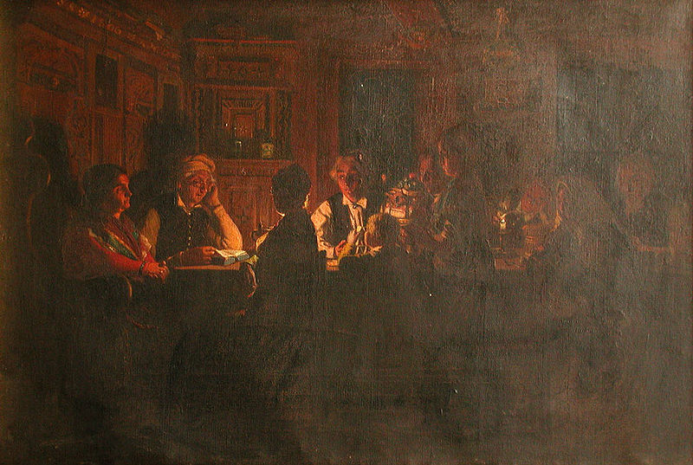
This is a painting from 1879 of a Household catechism exam.
For more details se the illustrations at the end.

Religion and Freedom of Thought
From what we have heard about Sweden in the 16th to the 20th century religion and freedom definitely are two entities that are connected in a problematic way. Two hundred years ago the priests probably felt what they did was useful and good. They probably felt people needed the harsh and authoritarian treatment. Otherwise they would disobey God and go to hell. There was no freedom of thought. Or put in a different way. It was not offered. What was offered was an already defined and unchangeable system. And religion was a given. In those days no one would ever carry the thought that a life without religion was possible. The situation was simply religion and no freedom of thought.
Today we live in a much more sophisticated world, also in what used to be less developed countries. When a friend of mine travelled in Kenya they went to see the Masai people. They live very isolated lives and absolutely without electricity. When my friend and his group drove up to them, they all flocked around the cars – because they needed to charge their mobile phones!!
We’ve come a long way also in respect to immaterial phenomena such as civil rights, human rights, freedom of speech, being equal before the law etc. In Sweden people were allowed to worship they way the chose. It even became accepted not to worship at all. Movements opposing religion were allowed to operate. The peak in this development was maybe the so-called Death to God movement, where Nietzsche can be seen as the most vocal voice.
We are in a very different place today. It is almost as if we have full freedom of thought but no religion, exactly the other way around compared with Sweden in the 17th century.
What is going on? Did we lose something, or did we win something? Or both? And is there a way forward to something healthier where we can have both religion and freedom of thought?

Your Love is Your Life – Your Life is Your Love
Going back to the allegory of child, youth, adult we see something similar in how people look at their lives the more sophisticated and developed they get. A child accepts to be told what to do. Brush your teeth, do your homework, go to bed and so on. Simple people in a traditional, narrow, underdeveloped social setting will more easily accept to be told what to do. You work with the crops. You make shoes and so on. But truly there is more talent and creative power in people than what such a rudimentary life style allows for. We have all heard wonder stories about people coming from nowhere and then becoming famous singers, inventors, political leaders etc.
When people are given the opportunity they try to develop their talents, they chose what to do. They make an effort to see who they are and to achieve what they see lays within reach. If you want to get to know a new person there is a good question to ask: - ‘What do you love to do?’ A teacher might say teach. A car mechanic might say fix cars. They could also say other things. Play the piano, but the talent or the circumstances were not quite enough to make a living of it.
We could ask, - ‘What is at the core of your life?’. Teach, fix cars better than anyone else, play the piano. What people love to do is almost synonymous with their deepest love.
If you want to get to know a new person the first question is not – ‘What’s your faith?’ or what’s your philosophy of life?’ My point here is that love is a much deeper thing than philosophy of life or religion. And this has to do with freedom and faith conversations.

Good People Revolt Against Oppression and Injustices
If we raise our eyes beyond the individual and his love or life, I think it is fair to say that we can think in a similar way. People want things to be good around them. Yes, we have varying preferences, but we all want things to be good, well organized and pleasant around you. I does not matter that much what political party rules the country as long as it does it in an orderly way. We know all too well what it is when a country is not ruled at all or ruled by a tyrant.
And to take this a step further, good people revolt against oppression and injustices. People want to see good manifested in their own lives, in other people’s lives and in the world.
An example if we go further afield is the broad and intense protests in India after a woman was raped on a bus by several men and who later died. It was a mass movement. They want goodness and innocence to be honoured and protected by the law and by those who enforce the law.
On a grand scale we this in a more political context. Lately we have seen how people in Turkey take to the streets to oppose the decisions of –maybe – corrupt political leaders. We see it in many other ways too where people organize themselves to defend their rightful part in wealth and development.
But we can also see this on a moral and religious level. Even if Swedes are not professed believers they are still concerned about ethics and justice. They also pay a lot of attention to their children and their upbringing. That is not outright religion but it has to do with values, morals and ethics. They take responsibility, make decisions, and don’t put up with injustices.
In short: people want to see good manifested in their own lives, in other people’s lives and in the world.
So if people have this longing for good things for themselves and for others, they must also accept the responsibility of those wishes. They realize that everyone’s decision has an effect on everybody else.

Taking Responsibility for One’s Own Life
To be responsible for one’s life. To preserve one’s energy. To stick to one’s goal.
If you are able to express yourself in terms of doing what you love to do, it becomes very important to make the right decisions. I think people have an urge to be in charge of their own lives, and therefore to make their own decisions.
After all, a sensible, rational person takes responsibility for his or her life. We make our own decisions and we have to take responsibility for what we do. We cannot blame another person. Therefore we put a lot of energy into watching what’s going on in the world around us. We react, we feel, we reflect, and we act. Let me take one example:
A newly married couple are looking for a more permanent place to live. It is a big decision. They watch what’s going on in the world around them. Some people buy houses. Some rent and save money for a few more years. Some add working hours to a high level and sacrifice a comfortable home life to save the money needed. Some don’t care and live off their parent’s assets. Some live in poverty and deprivation because of substance abuse. They watch a lot of things. And the decisions they make are something they will have to take responsibility for.
Or if we make the case more spiritual we can say some people have values, some have not. Some spend some time on finding a few guidelines and then they are content. Others keep looking all their lives for still better ideas. But what they have in common is to invigorate their mind so that they can make better decisions.

The Relevance of Churches
If religion and a faith in some kind of God is involved our discussion becomes even more interesting. What does the sensible, rational person look for in his or her decision-making?
Churches and other spiritual communities are like a market place for useful ideas when it comes to one’s moral and spiritual values – values that will affect how they behave when they buy a house, establish a family, care for their parents, look for jobs etc.
Maybe it is allowed to say that the better ideas people have the happier they will be. DP What would life be without pleasure and delight
What is life without delight and pleasure? It is not something living but lifeless.
Everyone calls that good, which from the love of his will he feels to be delightful, DP 195
The questions are not theoretical ones but practical. It is not
- About whether to get to heaven or not, or to go to hell or not;
- about being saved or not (from what?!)
- because a person with authority told you so.
Instead it has to with how useful it is. People ask how the knowledge we have can be used in daily life. When was the first time you saw a mobile phone? Maybe you asked: ‘Can you make a phone call with that funny looking thing?’ But you did not say: ‘Hi, there! I need help to find the nearest petrol station. Could you google it for me, please!’ What service can we offer those who show some interest? And even more, how can we become relevant to lots of people who potentially would be very interested in what we have to offer?
There are some interesting developments around the world within the main Christian denominations. The best example is probably the Catholic Church. Just recently I heard that the new Pope had declared, in the morning Mass on 22nd of May, that “all of us, even the atheists, are redeemed with the Blood of Christ: all of us, not just Catholics. Everyone! Even the atheists.” That’s provoking, but the main message was putting good ahead of truth:
”If we, each doing our own part, if we do good to others, if we meet there, doing good, and we go slowly, gently, little by little, we will make that culture of encounter.”
It certainly was provoking, because five days later a Vatican spokesman announced, ”The Pope was wrong and that atheists still go to hell”.
The 2nd Vatican Council was held 1962-65. Many important changes were decided during that meeting. The two most important ones were that everybody was allowed to hear their native language in worship services, and that they were allowed to take both elements of the Holy Supper. Well, this is a side issue, but the Catholic Church is undergoing major changes, and since it is the biggest Christian denomination it is of great importance.

Attack on The Faith of Our Youth
Many of us here are parents and pastors, and of course we – and of course others as well – have a great love for our children and young people. They are the future. We want so much for them. We want everything to be so good, and we want them to have a living faith.
So when we look out the window we see so many bad things: drugs, crime, adolescent sex, lose moral values, a war on religion and religious values. Hell is upon us. What shall we do?
But is it that bad? Or is all of that happening for a reason? Does God have a plan? A good plan for all of humanity?
Did God invent the mobile phone to save our young people?! Here is an extract from an advertisement for a book about how young people use their mobile phones:
”1 billion people under the age of 30 now own a mobile phone. Every single young mobile owner has a story tell and new way of using the device adults haven't even thought of yet.”
A lot of research suggests that young people are very different from the generation that has leading positions in church organizations. You will hear more about this from Dr. Hogan.

Main Beliefs in the Swedenborgian Faith
Before I go on to tell you about my faith conversations I think it is necessary to have a some idea of what the New Church stands for, what the emphasis is or what the main differences are compared with mainstream Christianity.
It is different and those differences are what catch my eye when I talk to people, not because I am a Swedenborgian minister myself, but more because I am amazed at the reactions. Yes, it strengthens my faith and makes me even more convinced about Swedenborg’s claims of being an evangel for a new era. Big words, yes.
First of all I should say that Swedenborg himself did not begin a separate church organization. He saw himself as the “servant of the Lord” as he put it on the title page under his name in his last published work, “The True Christian Religion”. And as such a servant he firmly believed that his works would be instrumental in giving a new understanding to the Christian world. He speaks repeatedly about a New Church or a New Christian Church. There is no doubt that he is referring to Christianity, but it has been an open question whether that was meant to be a revival of the then existing Christianity or a completely new entity. He defines the church as being first in the hearts of people and then an organization.
At the end of the 1700’s a number of individuals who were readers of and believers in Swedenborg’s writings decided to set up a separate church organization with an ordained priesthood and public worship services. In 1788 a call was sent out to gather at a Conference that would decide on this matter. That is the beginning of what today is known as “the New Church”. Using the founding documents of that movement gives us a good summary of Swedenborgian beliefs:
- The Lord God, the Creator of Heaven and Earth, is One in essence and in person, in whom is a Divine Trinity, consisting of Father, Son and Holy Spirit, like soul, body and operation in man, and the Lord and Saviour Jesus Christ is that God.
- The Word of the Lord is Holy, and it contains a threefold sense, namely, celestial, spiritual and natural, which are united by correspondences, and in each sense it is Divine truth, accommodated respectively to the angels of the three heavens, and also to men on earth.
- Immediately on the death of the material body, man rises again as to his spiritual body, wherein he exists in a perfect human form, and thus death is only a continuation of life, a life that is lived in a so called substantial world that is just as real as this one.
- Charity and faith are mere mental and perishable things, unless they are determined to works, and exist therein, whenever it is practicable.
- Repentance is the beginning and foundation of the church in man, and it consist in man’s examining himself and in abstaining from evils, because they are sins against God.
- The Lord alone effects regeneration or the new birth during man’s cooperation, and it is a gradual, not instantaneous work.
- In proportion as man is regenerated, in the same proportion his sins are removed, and this removal is what is meant in the Word by the remission of sins.
- There is no predestination and every individual can be reformed and so be saved and go to heaven.
- The Last Judgment has already taken place in the spiritual world, in 1757, and the Coming of the Lord according to Mt 24:30 takes place in the literal sense of the Word, and that is where the Lord can be seen.
These are some of the main teachings in the New Church. They are all based on the Bible, and Swedenborg’s writings give clarification to the Biblical message of loving the Lord and loving the neighbour, the Two great commandments.

Background for These Faith Conversations
In my conversations I do of course “come from somewhere” in my thinking, in my approach, in my expectations. Here are a few thoughts.

Christianity
Many Christians are upset about the influence from Islam or from agnostics or non-believers. The reality at least in the Western world seems to be that Christianity is defending itself, not going forth in strength. Here is an example from Carson’s book on Tolerance:
“At the risk of sounding paranoid or petty, I must say that a disproportionate part of the intolerance that masks itself as (the new) tolerance is directed against Christians and Christianity. … In several countries … legislation has been passed that has resulted in Christian pastors being hauled before the courts, and sometimes found guilty of hate crimes, on the ground that they have given public addresses that contrasted Christianity and Islam in ways that were judged to vilify Islam. I know of no instance in these countries where similar charges were brought against an imam for comparisons running in the opposite direction.”

‘Pagan’, ‘Atheist’, ‘New Age’
At the end of this conference some of you will travel to Adelsö outside Stockholm and there you will meet a person with a full-blooded pagan faith. In the name of tolerance and democracy this is possible. Thank God! When we serve our God, whatever name we have for our God, we cannot, and should not expect to have any privilege or ‘fast track’. There is competition and only reason can convince a person of what is the best path for them.
Carson discusses the problem of being intolerated by the public. But he concedes:
“In the long haul, there can be no freedom of religion unless people of competing faiths and of no faith are free to proselytize, free to try to convince others.”
We have to live together and make the best out of it. That was also Pope Francis’ message on 22nd of May 2013:
“Instead, this ‘closing off’ that imagines that those outside, everyone, cannot do good is a wall that leads to war and also to what some people throughout history have conceived of: killing in the name of God. … We all have a duty to do good. And this commandment for everyone to do good, I think, is a beautiful path towards peace.”
This is in complete agreement with what Swedenborg says:
“In the Christian world it is their doctrines that cause Churches to be distinct and separate … This situation would never exist if they were to make love to the Lord and charity towards the neighbour the chief thing of faith. In this case their doctrinal differences would be no more than shades of opinion concerning the mysteries of faith which truly Christian people would leave to individual conscience, and in their hearts would say that a person is truly a Christian when he lives as a Christian, that is, as the Lord teaches. If this were so all the different Churches would become one, and all the disagreements which stem from doctrine alone would disappear. Indeed the hatred one man holds against another would be dispelled in an instant, and the Lord's kingdom on earth would come.”

Faith Conversations in 2013
Now we come to the actual theme of my presentation. In my proposal I said:
“The individual is given - or demands - more and more freedom to decide how to live his or her life. … In faith conversations today a person’s freedom has to be given complete respect.”
A leading principle in Swedenborgian faith is that it must be “permitted to enter into the mysteries of faith with the understanding.” Thus that is a starting point for me, and that is combined with the thoughts expressed so far about respecting people’s freedom to think for themselves, explore different traditions, religions and philosophies, and from reason and experience choose what seems to be most beneficial on their spiritual path.
I have three basic principles as guidelines in my conversations with people about our faith. They are:
- To respect their spiritual freedom;
- To respect their ability to think in an intelligent way;
- To respect their innate need to find ideas that make sense and help them in their lives.

Christianity Around the World
The world we live in has such a variety of people, culture and traditions, so it is obvious that faith conversations will differ from country to country. I have made an attempt to categorize geographical areas as different spiritual states. Christianity was born in what I call the old world and spread mostly to the Wests within the old world, i e Europe. It then spread to the new world, the Americas. There was also another movement from about the same time the Americas were discovered, namely the colonization of Africa and parts of Asia.

Europe | Christianity is old and the dominant faith
America | Christianity is new and the dominant faith
Africa | Christianity is new and although the dominant faith has kept much of traditional faith components
Near East and South Asia | Christianity is mostly new and a faith in minority
Far East Asia | Christianity is new and a faith in minority
This is too big a subject to dig deeper into here, but this is just in order to underscore that a faith conversation in Norway, India or Cuba would have some interesting variations.

Scandinavia
Obviously Scandinavia belongs to an area with a well-established Christian church and as was pointed out earlier with a very strong history of being purely Lutheran after the Reformation. This is true for all for countries, Denmark, Norway, Sweden and Finland. It therefore makes sense to separate out these countries from the rest. These are the countries form which I also have the most experience.

Groups visiting the church
One of the most interesting settings for a faith conversation takes place in our church in Stockholm. The church is located in a central place and we often have different groups come to visit the building, which is beautiful, different and new to most of those groups.
When they come they expect a general presentation of the church building, the life of Swedenborg and maybe a few ideas about the theology. Most people are very nice people. Generally speaking they are, or have been, married, have children and grandchildren. They work or have worked for many years and are good citizens.
They have a basic knowledge of history, the culture they live in, the political situation in the world, and a basic knowledge of the Christian faith. Some go to church, many feel they have an on-going connection with “the Church”, and a few would admit they are churchgoers.
Since the sanctuary with all its decorations lends itself to a conversation about Christianity, Swedenborg and Biblical symbols, it is very easy to get into a relaxed conversation about life issues.
One example is Jesus Christ and the Trinity
I find that there are two types of reaction to the question of the Trinity. One is to quote the creed from memory and with a sense of obligation, thus with little participation of reason and with no sense of a real God. The other is to admit to close to complete confusion about the question.
Swedenborg’s explanation is straightforward. God Himself, in Whose image we have been created, is in a human form, albeit invisible. He decided to come on earth. He sent Himself. That is the virgin birth. The visible person Jesus Christ was God within and a normal human being without, in the sensual, physical world. Throughout the 33 years of His life He made all of His human Divine, from within, step by step. This is what is called the glorification. By the time of the resurrection all of Him was Divine, also the body. That is why the tomb was empty. Now the Father and the Son are One. Jesus is God.
Swedenborg then describes the Trinity in very simple terms. The invisible soul is “the Father”, the visible person or body is “the Son”, and what proceeds from Him is “the Holy Spirit”. This whole mystery is explained by these simple words in John: The Holy Spirit was not yet …” Jn 7:39.
And then he goes on to say that every human being is the same. We cannot see each other’s souls but we know they are there because otherwise we would not live. We can see the body, the real person, and when we speak and act something proceeds from us.
This explanation opens a door to many people who hear it. God becomes someone they can picture in their mind. They have been fed.
Another example is life after death
This subject is inspiring to talk about, especially with older people. There are a couple of reasons for this. They are beginning to sense that life on this earth will not last forever. They have lived a long life and wonder what it was all about. Why all the hassles?! Why all the pain?! But also, what will happen with all the love, the warm feelings and tender relationships they have with their spouses, children, grandchildren, friends.
Swedenborg has – again – in my mind a very straightforward and self-evident description of life after death. First of all it takes place now that is when we die. We do not rest in limbo for an indefinite number of years, decades, centuries, but life goes on right after death. That life is just as real as the life we live here. We have spiritual bodies that are substantial, that is consist of substance, let’s say material stuff of a different kind in a different world. Add to that that all illnesses, limitations and so on are taken away. Add to that that old people become young again.
With this explanation it gets very easy to talk to a widow about her husband and that they will meet when she dies. Or about a child that died young.
What will we do?, might be a question. My answer is this, and everybody immediately understands. Heaven – because we now talk about heaven – is a place where everybody wants to be nice to everybody else. So in what way can you be nice to each other and still have a good time, not a boring time? You do what you most love to do. Do in the sense of actively producing something, using your creative powers.
This is a real world with real needs. Angels eat, they live in houses, they read books, they tend the garden and so on. If you have been a teacher and loved it above all you will want to continue to be a teacher. And the pupils will be ever so more attentive and clever, and you will find new, wonderful ways to teach. Just enlarge that image and you will see what a lot of joy and creativity there will be.
This is something normal people understand. Swedenborg relates a situation where newly arrived spirits were allowed to live their phantasies about heaven. Some loved food and were allowed to have wonderful feasts day in and day out. It did not take long before they couldn’t stand it any longer. Others imagined heaven would be to praise the Lord with songs and prayers forever. After not very long they ran to the doors to get out of the worship place they were locked up in. They all realized that heaven is a kingdom of uses. People, angels want to use the creative force that comes from the Lord, and they want it to become of use to everybody around them.
A third example is the Bible
A copy of the Word, the Bible, is kept on the altar as a central part of the liturgical symbols. I explain to the visitors that in the beginning of the service the minister opens the Word and lets it lie open for the duration of the service, and that this is a symbolic way of saying that the Biblical texts now are opened up to a deeper understanding. Swedenborg gives in his works a full, detailed exegeses of Genesis, Exodus and Revelation. In doing this he gives references to many, many other parts of the Word and therefore gives us explanations to much more than just those three books of the Word. But more than that he presents a set of systematic hermeneutics that he calls the science of correspondences.
The literal sense is symbolic or allegoric in every sentence and word. The language of symbol or correspondences is consistent throughout the whole Bible. ‘Rock’ has the same meaning in the OT as well as in the NT, in Ex 17 as well as in Mt 16.
Again, this strikes a chord with these normal people on a cultural, architectural visit to our church building. To many people the Bible does not mean much. And others would like the Bible to mean a lot to them – it is the Word of God – but when they read they get upset and put it aside. Others are stuck with Biblical phrases – a bit like the creed and the Trinity – and from some fear or from historical faith and a false loyalty family, childhood priest or the like they are stuck.
I will just mention three examples of how this kind of faith conversation has an impact on their understanding and growing acceptance of the Bible.
The creation story
Swedenborg says emphatically that the Bible in all its parts have a spiritual message for every person, everywhere and in all times. But the message is for the most part hidden within the literal sense, within the stories, the parables, and the historical narratives. Therefore we should not be looking at the creation story as a description of how the physical world came into existence. The Bible is not a book about physics but about the spiritual well being of or rather healing of the human soul. The creation story is a symbolic explanation and teaching of how the spirit develops from nothing, the void, to fullness, the image and likeness of God. It is so obvious that more and more life is created, more and more complex creatures, and finally human beings.
The wars in the Old Testament
More than anything else people are upset about the cruelty exhibited in many stories in the Old Testament. Since we are so used to think of this as real history-, which it is as well – it is hard for us to read this as allegory. But when we read tales and stories to our four, five year old children we gladly give them horrifying stories with cruelty and violence because we know deep down that it is an allegory of good fighting evil. It is the same thing in the Old Testament. The simplest way to take the heat out of the argument against all the accounts of war and slaughter is to ask a person if there is a battle going on inside, in the mind, in the soul. And the answer is yes. When we are tempted to do something that violates the Ten Commandments, we surely want to kill the evil that attacks.
“If you only believe”
Faith, yes, but what about works? Does Jesus really mean that as long as we believe in Him we are saved? People want to see reality in their spirituality. If it does not work it is not relevant to them. So how can we save the idea of faith and still make it relevant? Jesus surely wants people to become good people and do good to each other. Works are part of the deal. If Jesus is our personal Saviour then He is a person we know and turn to as a real, living Person. Suppose you say to your boss at work that you believe in his principles, but then you go and do something that is altogether opposed to those principles! You can’t have faith and not live what that faith defines.
- - - -
My assessment – and I have received confirmation several times – is that they walk away more content than when they came. They have been fed spiritually. In full freedom. Using their rational mind. And the questions that are important to them have been answered at least in part.
I think I have lived up to the three principles:
To respect
- their spiritual freedom;
- their ability to think in an intelligent way;
- their innate need to find ideas that make sense and help them in their lives.

Internet, Scandinavia
Through our website, NYAKYRKAN.SE, we get a steady stream of inquiries. What I find interesting with this interaction is that the person is more or less unknown to those of us who answer their questions, and that they therefore supposedly speak from their heart without any fear about being censored or told off. And if they are, they will simply stop the conversation.
What I thus see is an environment or a space in which the person is in complete spiritual freedom. When they write in they have of course also spent some time reading and digesting the material they have found on our web site and probably on other Swedenborgian sites. They are somewhat prepared in their own mind and so the comments and questions come from a sincere interest to learn more, understand more and come to a finer judgment of the views they have found with us.
Practically all of this is this conversation is in Swedish, Norwegian or Danish, so the quotes I use are my translation.
Person 1:
Q:
Since what the New Church and Swedenborg advocate is a kind of Modalism, I wonder how you explain the birth of Jesus, I mean the conception. The Mormons believe that God the Father Himself made Mary pregnant in His own Human body. But how do the Swedenborgians explain this, since you in a way deny the general Christian doctrine of the Trinity.
A:
In this case the answer was pretty long:
You are quite right. There are not three persons. That is what Modalism tries to avoid, but it gets to thin just to talk about three aspects. God has always been and is One, and He has always been in the Human form. The angels see Him as a Human Being. The only thing that was missing before the Advent or incarnation was a presence of the purely divine in the flesh. This had two things as a result:
- the Redemption, which means a complete victory over the hells, and ordering of the heavens;
- a continued and eternal presence at our human level of the mind.
The latter means, paradoxically, that He became invisible but completely present. This is also connected with the question about the Holy Spirit. See Jn 7:39.
Swedenborg talks a lot about this, and this is just one quote: ”That He was born of the virgin Mary is known, yet as another man; but when He was born again, or became Divine, it was from Jehovah who was in Him, and who was Himself as to the very being of life.” Arcana Cœlestia, # 2798:2
And about the conception he says:
“The angel said to Joseph, the bridegroom of Mary, in a dream, that that which was begotten in her was of the Holy Spirit. And Joseph knew her not till she had brought forth her firstborn son, and he called His name Jesus (Matt. 1:20, 25). It will be shown in the third chapter of this work that the Divine that goes forth from Jehovah God is what is meant by the Holy Spirit. Who does not know that the offspring has its soul and life from the father, and that the body is from the soul? Can anything, then, be more plainly declared than that the Lord had His soul and life from Jehovah God; and as the Divine cannot be divided, that the very Divine of the Father was His soul and life? This is why the Lord so often called Jehovah God His Father, and why Jehovah God called Him His Son.” True Christian Religion, # 82:3
It is often repeated in Swedenborg’s works that in the case of human beings, as well, the soul comes from the father and the body, or the natural mind, from the mother. This means that in the Lord Jesus Christ the soul is God Himself, or more philosophically “the Divine” or the “Divine Essence”.
This is what is meant in the following quote:
“The Lord from eternity or Jehovah put on in addition this third degree by assuming a humanity in the world for the reason that He could not enter into this degree except by means of a nature like people's human nature, thus only by conception from His Divinity and being born of a virgin. For in this way He could put off a nature which in itself is lifeless, even though a receptacle of the Divine, and put on a Divine one.” Divine Love and Wisdom 234
Person 2:
Q:
Do you think that your religion involves your whole life, everywhere and always? Or do you think that your religion is important but does not have to occupy your whole existence?
A:
A few weeks ago we had a weekend meeting with the theme, Religion in Your Daily Life. It was about ways of letting your religion inspire your daily life in the sense of keeping your religion alive as much as possible during the day. But then we don’t mean a number of external religious practices such as prayer, meditation etc. but a disposition in your mind, a ways of reflecting before you act, open your eyes to get an idea of how the Lord is present and guides you to the right decision. It is about being a good person and treat your fellow human beings in a decent way. The more we do that the more peace of mind we will have. And more joy. That is why Jesus says: “These things I have spoken to you, that my joy may remain in you, and that your joy may be full.” Jn 15:11
Q:
In the Ten Commandments there is one commandment that says that you are not supposed to have any other gods on the side. Do you agree to that? And are you saying that it is not OK to believe in other religions or another faith if I at the same time belong to your faith?
A:
Basically this means you should not have any idols that is things that have nothing to do with God. While the children of Israel walked in the desert they made a golden calf to be their god while Moses was on the mountaintop to receive the Ten Commandments, Exodus, chapter 32. Compare this with what Jesus said: “You cannot serve God and mammon,” Mt 6:24. We say that people of all religions, no matter what name they put on their God, can find their way to heaven. But it gets more complicated and confusing if you worship Jesus Christ at the same time as Allah. We say that you should stick to your tradition, your religion, but then you of course show respect to Islam and other religions, and you can find inspiration and develop your spiritual life by reading holy books of other religions.
-- -- -- --
When I try to sum up what I hear then it is this:
- They feel they can relax, spiritually. Relax does not mean forget, ignore and go back to some kind of spiritual sleep. No it means the opposite. The mind becomes more alert and alive because they are allowed to use their rationality, their imagination and most importantly relate the ideas they hear to premonitions they already have of how it should be.
- They say the have found a safe place, or a home, a final destination where they can rest, set up their tent and find peace of mind.
Again, I think I have lived up to the three principles:
To respect
- Their spiritual freedom;
- their ability to think in an intelligent way;
- their innate need to find ideas that make sense and help them in their lives.

Students, grade 8-12, age 15-19
Since we are an established church community in Stockholm we regularly have students either come personally or sending in questions by e-mail. Often a class has as a task to present a denomination to the whole class, either orally or in a written report. Sometimes they have a set of questions constructed by the teacher, but often they have their own topics or come with a fairly open-ended approach.
Everybody has to do the subject “Religion” in our schools, so there is not much of a bias in who comes. Most of the time they have chosen themselves to come to us, and that in itself allows for some bias, probably in our favour, but I am not sure. I could also be, “This is weird, we’d better find out”, but I think most of the time it starts with an interest. They have found something in our material on the Internet or elsewhere that has caught their attention.
I have found that just like with the older people coming on the afternoon excursion to explore new architecture these young people can also be put into categories of Christian background and knowledge. But whereas the older people are looking back on their life and maybe on what is to come, the young people are just entering life as adults soon to be and therefore with a sense of responsibility for their own lives and own choices. It opens for some pretty interesting conversations.
Sometimes these conversations are truly spiritual experiences. They are right at were they should be, open in heart, inquisitive, looking for good answers for their lives. More often than not they say they are grateful for the things they have heard and discussed.
Again, I think I have lived up to the three principles:
To respect
- Their spiritual freedom;
- their ability to think in an intelligent way;
- their innate need to find ideas that make sense and help them in their lives.

Church coffee
In Stockholm the church service is always followed by a gathering in the social hall. We sit down for coffee and cake or light refreshments. No one has to do this, but the rule is that people do and feel sorry when they can’t. The conversation is anything from light to serious, spiritual and deep. It is not structured at all, but there are always interesting discussions going on. This is also a good time for newcomers to learn more and to get to know people in the congregation. We are often not more than twenty people, so newcomers feel there are enough people to disappear in the crowd as well as being able to strike up an informal conversation.
One of many good things about this is that new people get to hear from not only the minister but from many different people. They also see the young people and the children. Even if they don’t approach them they see that all ages are involved.
For some people it can be difficult to go to a new place. What will people be like? Will I be accepted? What will they require of me as a human being? Can I live up to their standards? I remember one person who in particular can illustrate what I find a very healthy position of our congregation. He came to our church coffee for the first time, although he had paid a visit to the church on a weekday several weeks before this occasion. I happened to sit close to him and heard the conversations around him. Much of it was about astronomy, physics and things far away from theology. And there were jokes and laughter. A month later we had lunch. After a good while he told me about that Sunday. His comment was: “When I sat down and listened to those conversations I knew I had found my church.”
I think I want to say I am proud of that, because what he meant was that he had those questions in his head that I just listed above, and he found that we were perfectly normal people who talked about normal things. At the same time he knew and could see and had experienced deep conversations about definite life-changing spiritual ideas.
I can quote many more who have had the same experience of simply being embraced by a spiritually good sphere but without any exterior quasi-pious mannerisms among our members.
Again, I think I have lived up to the three principles:
To respect
- their spiritual freedom;
- their ability to think in an intelligent way;
- their innate need to find ideas that make sense and help them in their lives.

Alcoholics Anonymous
Among the things we do or rather support in our church is an AA (Alcoholics Anonymous) group.
Everybody knows, I hope, that this movement has been tremendously helpful and effective and saved many lives. I hope it is also well known that this is a religious movement where free will in spiritual matters is at its core. Reason is number one. What a person does in the twelve steps has to be accepted by one’s reason. And it does. It actually says in The Great Book: “One loving, almighty, reasonable God - my Creator - the Higher Power available to all mankind”.
Reason and freedom. And convincing oneself that there is no other way out. The same thing is true for any true religion, with our without addictions in the picture.
The three principles I use are at the core of their system:
To respect
- their spiritual freedom;
- their ability to think in an intelligent way;
- their innate need to find ideas that make sense and help them in their lives.

Countries Outside Scandinavia
The countries outside of Scandinavia I have visited are in themselves very different. There is one group of countries that have some similarities, namely the Czech Republic, the Ukraine, Georgia and Russia. I travelled to Russia in the early days after the demise of the Soviet Union about twenty years ago but have not been there for the last ten years.
I leave out Georgia even if that is a very promising country for us. As late as yesterday, on the 19th of June, a day we celebrate as New Church Day, our man in Tbilisi went to an interdenominational conference and festivity. He met the leaders of the Armenian-Catholic Church, the Roman Catholic Church, the 7th-Day Adventist, the Baptist Church of Georgia, the Sunni Muslim and Shiite Muslim leaders.
What these countries have in commons is of course the Communist history and seclusion from influences from the West and from religion. Russia is the worst case, but they all suffered from being cut off from a regular contact with and practice of the Christian faith in particular and other faiths in general.

Czech Republic
It’s been a few years now but my visit to he Czech Republic was very special in terms of faith conversations. I was invited to give a lecture on Swedenborg, his life and works in two places, one open-ended ecumenical and a bit New Age place in Ostrava in the Eastern part of the country and the other one at the Scandinavian House in Prague.
I had been told not to be too “religious” because people in this country are a bit anti-church. Since I don’t speak Czech everything had to be translated. I gave a 45-minute lecture on Swedenborg’s life and work and was not too “religious”. After a short break we had time for questions. We kept going for more than two hours! And all of the questions, all of the questions (!) were on “religion”.
They had many questions on the Bible and quoted verses and alluded to stories and ideas from the Bible. They really wanted to know and understand. Another big issue was life after death. Since Swedenborg has given us a lot of information on that I could feed them in a substantial way.
When I left they were extremely grateful. Some were in tears. Unforgettable.
In Prague the venue was slightly different and the reaction more academic but still interesting and positive.

Ukraine
I have travelled to the Ukraine for about twelve years, to Dnepropetrovsk and to Yalta. A group of young people started a Bible study circle about fifteen years ago. They eventually found Swedenborg’s works when they were looking for commentaries on the Bible. Then they began translating his works into Russian and still do. This is where I came in. I speak Russian and it was obvious that I should visit them. By now I know them very well. When I go there we have conferences or gatherings with 20-30 people. Apart from that there are of course informal conversations as well.
Since they are very well read in Swedenborg’s works it is a different kind of faith conversation. They are, shall we say, already convinced. And from there we launch on deep discussions, and I mean deep. Once I had a minister friend from the US join me, and he was amazed at the quality of the meetings, the knowledge they had and the sincerity about seeing how these ideas would help them in their daily practice of charity and neighbourly love.
One of the great mysteries in the Christian faith, maybe the greatest is the Lord’s incarnation, resurrection, and Who He is after the resurrection. When my American friend was there a subject that came up was the Lord’s resurrection body. Swedenborg has a lot to say about this. For them this was not some arcane, subtle subject they would leave to theologians to battle over. They felt it was part of their living faith to try to understand their God even more.
For me, and my American friend, it is certainly uplifting and inspiring to have that kind of conversations, because deep down we know we will love the Lord even more when we have a fuller understanding of His redemption and salvation of mankind.

India, Kerala
India is a very bid and diverse country. It has more than a billion inhabitants and it is the biggest democracy in the world. It has a long and highly developed culture with a rich religious literature and several religions.
The part I have visited is the state of Kerala. Whereas the proportion of Christians in India as a whole is about 5 % Kerala has 20 %. This is noticeable. There is next to proof or at least a strong legend that Christianity was brought to India by the disciple Thomas. A definite and lasting establishment took place in the 1500’s when the Portuguese colonized that part of India. The Catholic Church is the largest of the several denominations that have a presence. Next in numbers is the Pentecostal movement.
We now have one congregation and one ordained minister, Peter Devassy. We also have groups in other parts of India. I first went there in 2007. To my surprise not many people spoke English. Basically everything I do has to be translated. It makes it more difficult to have a one-on-one conversation, but having been there several times by now I still feel I have a good idea of how people respond and think about religion.
A very important difference with India compared with all other countries I have mentioned is that “everybody is religious”. The existence of God is self-evident. Rituals, daily or weekly, are natural to everybody. Saying a prayer is something that happens all the time, standing in a ring, holding hands and have somebody speak freely and out loud. Being a minister I have lots of people coming up to me saying, ‘Pray for me’.
What I find is humility, trust in God, hope and forbearance, kindness and a sense of wanting to do one’s duty. I know there are darker sides too in Indian society like greed, envy and violence, but in my conversations I don’t hear much of that. Sometimes a person might describe a challenge. One person was accused by someone (from the outside) and was taken to court, but there again I could see trust and hope. There was a good end to that story.
A real challenge has been the other churches. Kerala is a bit like Sweden at the time when Household catechism exams were held. If a person does not show up for church it will be noticed the week after. It has been a real struggle for our minister, Peter. People are interested but the pressure on them to leave the old church is very high. After several years I continue to see many of the people who were there from the start but many of them have not dared to take the step. Now, that is not all-important. Going with my ideas of freedom and rationality I accept that they need to do what seems most reasonable for them, but this is an important background for the faith conversations in India.
I would like to sample two ideas that are important to them. One is the doctrine of the Lord that is what is the Trinity. The other I could call trust and hope, which is something we capture in the concept of Divine Providence, a key concept in Swedenborg’s thought. Here are a couple of quotes highlighting this:
“The continual aim of the Divine providence is that man may become a heaven in form and consequently an image of the Lord.”
“Every happening or contingency which is otherwise described as fortuitous and attributed to chance or luck is something providential. Divine providence does its work out of sight and in ways beyond comprehension, for the reason that a person may be able in freedom to attribute that work either to providence or else to chance.”
When Peter found Swedenborg he had been searching for light that could give him peace about the idea of One God. The explanations of the Trinity he had so far heard did not satisfy his mind. He was raised a Catholic and therefore has had Christianity as his faith all of his life. I won’t say more about him, but this is an area that I have come back to many times during my visits, and I have found that people are very receptive and find consolation in the explanations we offer. There is no doubt in my mind that they worship Jesus Christ as their personal Saviour and God. In a Western context I find that the old Arian heresy is rampant. It is enough for many that Jesus is an ideal, whereas saying He is God goes beyond their inquiry or comprehension. But here they want to understand more.
The other doctrine I have picked out has to do with their trust in the Lord. India is a very diverse country with large differences in standards of living, even if Kerala is in a better position than the rest of India. There is a trust in the Lord leading their lives, but the concept is bigger than that, and I think that is why they want to talk about it more.
Another key concept with Swedenborg is regeneration. He does not talk so much about salvation, especially not salvation by faith alone, which he thinks is a gross misunderstanding of what faith in the Lord means. Regeneration means, according to Jesus’ words in John, Ch. 3, that man’s spirit has to be renewed. ”Unless one is born again, he cannot see the kingdom of God.” Jn 3:3.
Maybe the Hindu background and India in general with its strong tradition of thinking of karma as a burden to get rid of that makes this idea of regeneration according to Swedenborg so appealing. At any rate it is very practical and sensible. In two words it means that we don’t change over night from being sinners to be perfect. In Exodus Ch. 23 we have these enlightening verses. The enemies to be driven out are bad behaviours we carry within ourselves:
“I will not drive them out from before you in one year, lest the land become desolate and the beasts of the field become too numerous for you. Little by little I will drive them out from before you, until you have increased, and you inherit the land”. Ex 23:29,30
And Pope Francis said the same thing in that same message:
“If we, each doing our own part, if we do good to others, if we meet there, doing good, and we go slowly, gently, little by little, we will make that culture of encounter: we need that so much.”
In summary I find the spiritual climate in India a bit more restrained, accepting to authority. Not that I abuse that to my own benefit, but it is different from more Western-like cultures. But I still think I can repeat my mantra:
To respect
- their spiritual freedom;
- their ability to think in an intelligent way;
- their innate need to find ideas that make sense and help them in their lives.

Cuba
If you have not been to Cuba yourselves, you might be a bit surprised to hear the following:
In 1992 Cuba adopted a new constitution that is still in place that opened the doors to the freedom of religion. Article 8 says:
- The state recognizes, respects and guarantees freedom of religion.
- In the Republic of Cuba, religious institutions are separate from the state.
- The different beliefs and religions enjoy the same consideration.
When our little group
Cuba is not a copy of a dull, Eastern European country of the 1960’s. Cuba has a completely different spiritual, cultural and political heritage. The influence from all of Latin America, notably the Caribbean part of it, and from pre-conquest religions makes for a very different scene.
During my visit to Cuba in January together with six other people from five different countries we had the pleasure of seeing the president of the Cuban Council of Churches. The ecumenical approach was clearly put forward. As associate members they even had the Muslim faith and organizations not per se religious like Amnesty International. The president also said:
“People wonder why it is so hard to agree on doctrines and become more united, when in fact it would be more useful to learn about each other’s difference and appreciate that we can serve in different ways.”
This is happening in a country that by name still is Communist. But if so it is a Communism with different roots than in Europe. An important figure in Cuban history is Juán Martí. He is a national symbol and the founding father of Cuba as an independent state. Martí was a writer, a poet, and a freedom fighter in the war against Spain 1895-98, and actually died as a soldier in that war. But it is his ideas, his poetry and his thoughts that people admire and celebrate. And this man read Swedenborg, and studied Emerson who admired Swedenborg.
And when the new constitution was adopted in 1992 it had the mark of Martí. It paved the way for freedom of religion! Let’s see what it says right in the beginning:
WE DECLARE
“Our will that the law of laws of the Republic be guided by the following strong desire of José Martí, at last achieved: ‘I want the fundamental law of our republic to be the tribute of Cubans to the full dignity of man.’"
I have dwelt on the strong presence of Martí in Cuban life and culture because I think our cause to establish the New Church in Cuba is much helped by this.
This is some of the background for the faith conversations in Cuba. Four of us gave instruction to a group of more than forty people altogether and there was plenty of time for questions and answers.
Unlike India the approach was much more straightforward. I found the Cuban society homogenous and with a sense of equality among people. Having learned representatives of a new denomination come to Cuba to teach was not the least intimidating. It made for very interesting discussions. The setting was en ecumenical seminary with many adult students. I will just quote one young man:
“When I came I was full of doubts, but now I am really interested.” That interest has been growing ever since.
A question that often comes up is reincarnation. And such was the case here. We gave them two ideas that in combination are a good argument against reincarnation. Many feel rightfully so that there should be more to life than only this one we know of now. There are two solutions to that, either reincarnation or one eternal life beyond the grave.
Another principle that is attractive in the doctrine of reincarnation is that it provides for a continued development of a person’s skills and character. In this case to answer with eternal life does not do much, but if you fill in that idea with living images of what eternal can be – and Swedenborg does that – then it is much easier to see the “advantage” of a continuation on the other side without being thrown back in this world of miseries. I get a feeling many of them could appreciate that.

Challenging Questions
I want to deal with these questions separately. The biggest one is homosexuality. I am amazed by the strength of this issue in people’s minds, in politics and in culture and religion all over the place. My impression is that movement in favour of acceptance of a homosexual “life style” has gone much farther in the West than in other parts of the world. I see a definite dividing line between Europe and America including Cuba on one side and the other countries I have included in this study, Ukraine, Georgia and India.
Especially young people have a hard time accepting the “intolerance” and the harshness they feel are coming from those who stay within the Biblical framework. I see two ways to deal with this. One is to be a “hardliner” and hold fast to the Biblical teachings at the risk of losing a generation. The other is to teach what the Bible, and Swedenborg, says, and then says it is up to each individual to decide where to be on this question.
Swedenborg is very clear on this. And since he uses the two concepts of love and wisdom as forces permeating everything of creation, physical and spiritual, in God Himself, in the mind of human beings, and in an image in the union of one man and one woman in marriage, it is easy to uphold the principle. But it is not easy to get this across.
I wonder much about what in the Lord’s Providence this is about. Do we as a unified mankind have to become so universally tolerant and accepting in order to erase some kind of cruel strain in our heredity that this is needed? And that there is a next step where we can build a civil, moral and spiritual structure for our lives, where the true spiritual principles apply and yet do not lead to hate, exclusion and other bad things.
Another hot issue is women in the priesthood. There are similar sentiments in this. The younger generation see discrimination and has a hard time understanding theological arguments.
The attitude of a spiritual teacher must be to teach in truth and leave the message to the listener to judge and not force a belief on others.
With these and other hard questions like sex before marriage, cohabitation, adultery or promiscuity, abortion, euthanasia I don’t feel as confident in living up to my principles:
To respect
- their spiritual freedom;
- their ability to think in an intelligent way;
- their innate need to find ideas that make sense and help them in their lives.
Especially the last one is difficult. Do I as a teacher give them the right direction? Should I be more persuasive, in the name of God? How about leaving it to the Lord and trusting that He is in charge. I teach the truth and people around me ignore me. But the Lord does something with the seeds I sow. What I don’t know, but I have to trust He does.

Any Patterns?
This is a small attempt or just hint at how to assess the different kinds of faith conversations I have had. It is obvious, as I have already indicated that people react in different ways in different contexts and that they have different kinds of questions and interests.

Faith issue | God | Providence, God leading, trust | Salvation in terms of an on-going regeneration | Doing good to others
Country
Sweden | Solid Swedenborgian faith | Strong | Yes | yes
Norway | Solid Swedenborgian faith | yes | yes | yes
Denmark | Solid Swedenborgian faith | yes | yes | yes
Czech Republic | New, curiosity | New to the idea, open | yes | yes
Ukraine | Solid Swedenborgian faith | yes | yes | yes
Cuba | New to the idea, open | New to the idea, open | yes | yes
India | A simple “Trinitarian” faith. Believe in the Son of God | Strong | New, open | yes

Analysis
A theme in this presentation is freedom and rationality. People have an urge to be in charge of their own lives, and to make their own decisions, so the pattern we have is this:
- People have ideas about life, religion, morals and society.
- Since all of us – I presume - believe in God, God has ideas.
- We who professionally deal with ideas become an important agent in all this.
In these changing times we, the agents, have to adapt in such a way that we do not harm
- either people’s freedom to choose their own ideas,
- or God’s ideas.
Therefore we need to learn when to stay out and when to get in, get involved. Do we help people, or do with put obstacles for them to find their way to heaven? Do we help God or do we put up obstacles for Him to find people on earth?
I have put this together a test using one typical Christian or theological idea: To get to heaven

What do people say?
- I want a happy life
- I see injustices and I want to see them go away
- I see and do evil, and I want to see and do good
- I want to do good whether there is a God or not
- I don’t care about heaven or hell – I care about justice and fairness.

What does God say?
- I want a happy life for you, DP 324:6; Jn 15:11
- I want to see good being done in the world. Mt 24, I was hungry etc.
- I want you to stop doing evil and do good. Ez 18:32; Isa 1:16,17; Mika 6:6,8
- I will use whoever is willing to do good. The good Samaritan, Lk Ch. 10; the Syro-Phoenician woman, Lk 7.24-30; the woman at the well, Jn 4, etc.

What does/did traditional Christianity say?
- You are born in sin and your life is a misery. Gen 6:12; Lk 3:9
- You will end up in hell, unless you believe in Jesus Christ. Jn 3:118,19; Jn 14:6
- To get to heaven you must … (do what the priest tells you?)
- If you don’t get to heaven, you will burn in hell to eternity. Gen 19:24; Ps 11:6; Jude 1:6; Rev 19:20, 21:8
- Jesus is the only way, so Muslims, no matter how good they appear, will go to hell. Jn 14:6

What does the Swedenborgian Church say?
- Your true self is what is alive within you, good intentions or egotistic desires
- Your life is eternal and the way you choose will decide you destiny, heaven or hell
- But God is always on your side as long as you try to follow His commandments
- Freedom of thought and rationality is necessary for decisions that will become part of your inner self
- Knowledge builds conscience, not charisma
- Kingdom on earth can only come through people who do the good God wants us to do, Mt Ch. 24.
- All religions can lead to heaven

I am not looking for who is right and who is wrong but rather for the right attitude. Back to the theme of freedom and rationality and teachers of the Divine law must respect that. God does not want to frighten us but make us aware that might be moving the wrong direction. He also wants to help. We should be the same.
We all have different doctrines, and we all feel more or less controlled by them, but we can all work towards a teaching method that lives up to the principles I have used:
To respect
- their spiritual freedom;
- their ability to think in an intelligent way;
- their innate need to find ideas that make sense and help them in their lives.

Conclusion
It might be a bit arrogant of me, but I have such a strong feeling that what we are, what we stand for in the New Church, is very much in line with these changing times. The world is truly rapidly changing. We have to adapt to these new times. But how do we do that? What do we see happening? And how do we respond? We cannot say, “You have to believe this, because if you don’t …”. We, the teachers, are under scrutiny, not they, the ones who want to learn!
In the 18th century Sweden the minister came to the people to check their memorized knowledge of the Catechism. We will never get back to that. Now we have to find a way where people want to come to us. That is the goal and the dream.
But what would make them come? Think of all the people who pay a lot of money to learn new skills. They do language courses. They learn computer programmes. They get coaches to teach them different athletic skills. You can go on. They come and they pay because they see there is value in what they get.
It should be the same with a church or spiritual organization. We should be able to say: “Try to stay at home and not come to church next Sunday!”, and they would protest!!
So why would they come? Because we have been able to show them that the Lord is right when He says: “You shall know the truth, and the truth shall make you free.” Jn 8:32
But both religion and freedom have to be part of the game. “The times they are a-changin’” and there is no looking back. If what we do is not relevant they won’t pay us.
Let us think back to the system of the Household catechism exams. In that situation there was much religion but no freedom. Now on the contrary it is as if we have much of freedom but no religion. Therefore the charge to us is to make sure we get both, freedom and religion, or why don’t we say religion that emerges in a state of complete spiritual freedom. We can only do that if we are good servants of the Lord, and when we succeed - and we will - we will all together say: “This was the Lord's doing; It is marvelous in our eyes.” Ps 117:23

Thank your for attention!
An entry from the church records. Pay attention to the ”grades” to the right.

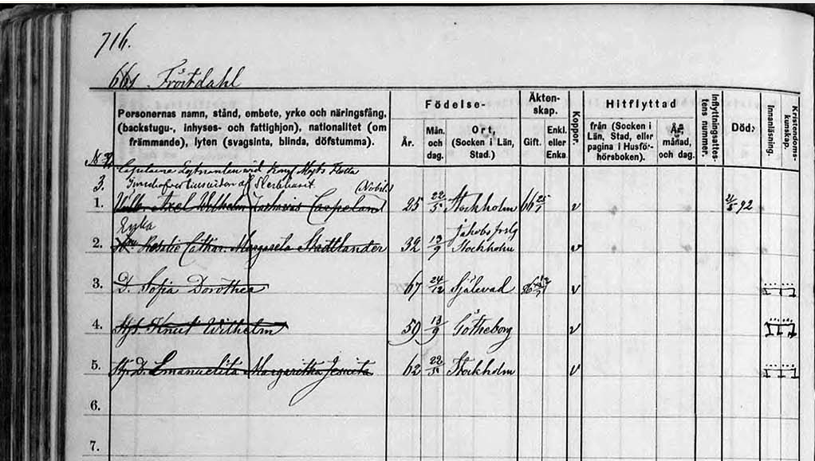
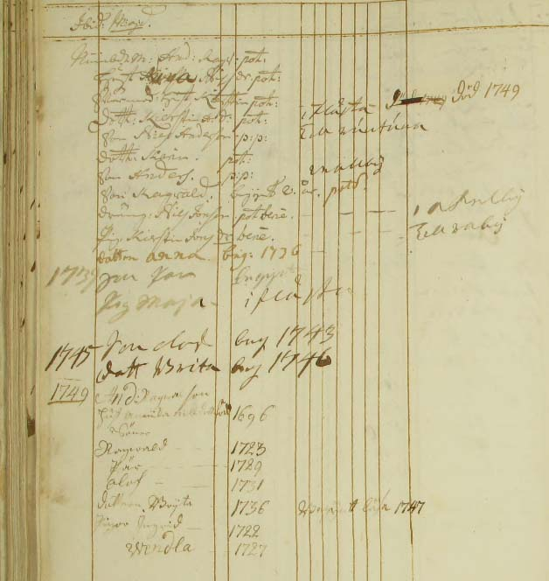

Symbols used for Household catechism exams
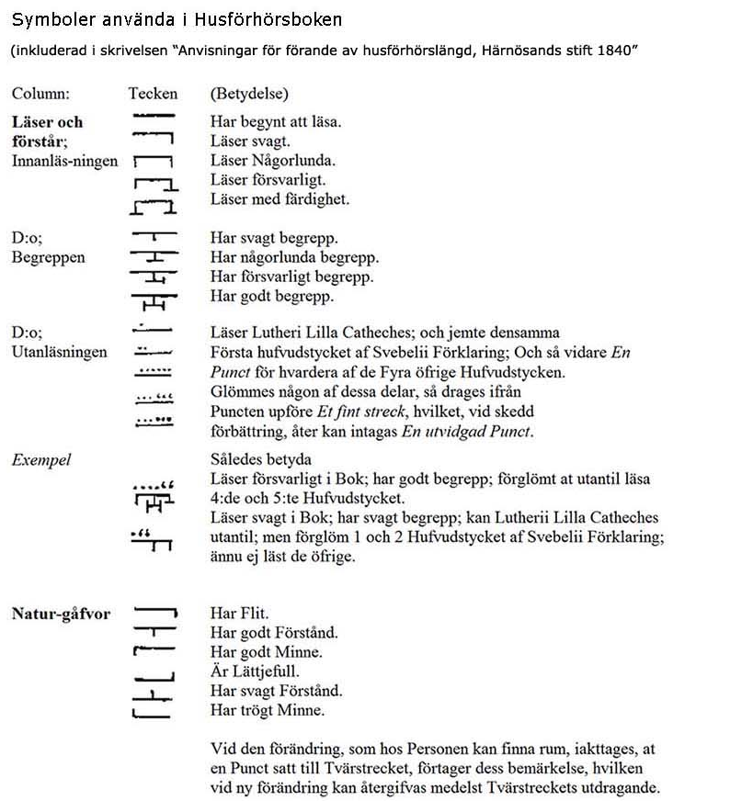
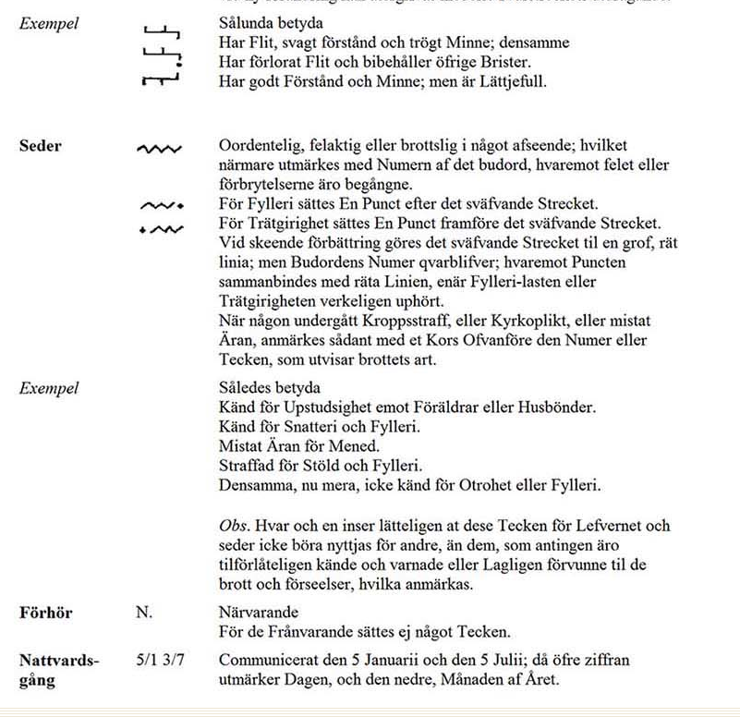

Bibliography

Carson, D. A., Telling Truth, Evangelizing Postmoderns, Grand Rapids, 2000
Carson, D. A., The Intolerance of Tolerance, Grand Rapids, 2012
Swedenborg, True Christian Religion and other works
Wikipedia
Internet, see footnotes

http://en.wikipedia.org/wiki/Religion_in_Sweden
Carson, Telling, p. 20
http://en.radiovaticana.va/news/2013/05/22/pope_at_mass:_culture_of_encounter_is_the_foundation_of_peace/en1-694445
Ibid
http://now.msn.com/vatican-corrects-pope-on-atheists-heaven
http://www.youthresearchstore.com/products/book-the-mobile-youth
Carson, Intolerance, p 40f
Carson, Intolerance, p. 44
http://en.radiovaticana.va/news/2013/05/22/pope_at_mass:_culture_of_encounter_is_the_foundation_of_peace/en1-694445
Swedenborg, Arcana Cœlestia, # 1799:4
Swedenborg, True Christian Religion, # 508
Swedenborg, Divine Providence, # 67
Swedenborg, Arcana Cœlestia, # 5508
http://en.radiovaticana.va/news/2013/05/22/pope_at_mass:_culture_of_encounter_is_the_foundation_of_peace/en1-694445
From my article in New Church Life, March/April 2013

